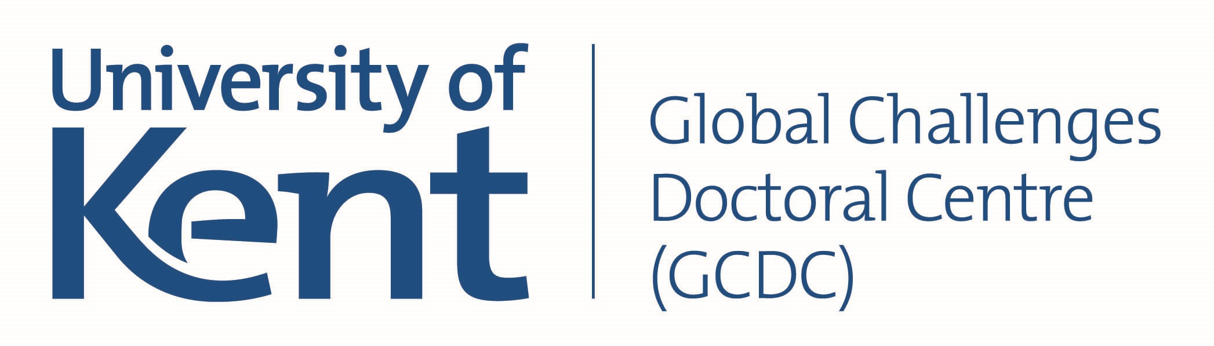
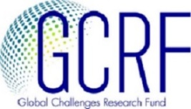

GCRF GCDC Early Career Researcher Training School
“Governance, resilience and order: Eurasia and beyond, under the pressure of global and regional change”

University of Kent, Canterbury
2-6 July 2019

Call for Applications

Within the framework of the GCRF Kent Global Challenges Doctoral Centre and the GCRF COMPASS project we are delighted to announce a Call for Applications for the first GCRF GCDC Early Career Researcher Training School (ECR TS), to be held on 2-6 July 2019 at the University of Kent, Canterbury (UK). Its main objective is to offer an opportunity for further skills development and exchange of ideas for PhD and Postdoctoral Researchers working on capacity-building and political, economic, societal and environmental developments in ODA countries.

The theme of this first ECR TS is ‘Governance, resilience and order: Eurasia and beyond, under the pressure of global and regional change’. The theme responds to current developments in the region and beyond, and the training school aims to ask how global and regional transformational change is affecting wider Eurasia. It will investigate how cooperative orders can be developed across the Eurasian space and how the region can best respond to current competitive challenges emanating from surrounding powers and beyond. To this end, we would like to explore the concepts of resilience as a new regime of governance and look at challenges and opportunities for growth and capacity-building, both nationally and regionally across and beyond the Eurasian space.

This Training School is organised in tandem with a large GCRF Kent Conference ‘Building Resilience’ (1-2 July), which successful candidates are welcome to attend. An early draft programme will be available soon here.

PROGRAMME
The ECR TS is run according to a European Consortium for Political Research format, offering in-depth discussion around submitted papers, with the best papers published in the format of on-line conference proceedings. The discussion sessions will be supplemented by skills training sessions, study visits and social activities. More specifically, the ECR TS will include:
- Paper presentations with time for in-depth feedback. Unlike most conferences, the ECR TS will provide an opportunity to present your work thoroughly, and to have a personal feedback session. Each presenter will receive up to 40 minutes for both speaking and question time.
- The sessions will be complemented by short research introductions to the work of Senior Scholars working in the field.
- Three skills training sessions, delivered by experts in the field: (1) Obtaining fieldwork funding for ODA-related research; (2) Publishing in international outlets; (3) Effective networking (exact topics to be confirmed)
- A social and networking event: a day trip to London, to visit Westminster, a policy think tank and government institutions.
- There will be plenty of time for socialising, including a welcome dinner and tours around Canterbury, to foster collaboration between Early Career Researchers and PhD students from different institutions.

Participants will be required to submit a 5,000 word paper in advance of the Training School.

SELECTION CRITERIA
Places are limited, with a maximum of 26 participants. External participation, especially from ODA recipient countries, is strongly encouraged.
Participants will be selected based on the following criteria:
- Paper’s suitability to the Call’s theme;
- Motivation for participation and explanation of how participation relates to the applicants’ studies and research;
- Participants are expected to have a high level of English, and be at an advanced level of research;

FINANCIAL SUPPORT
Accommodation and catering for all participants will be provided by the University of Kent throughout the duration of the Training School.

External participants from overseas institutions can apply for a bursary of a maximum £1000, for travel and visa costs. The outcome of this additional application will be communicated at the same time as that of the main application.

APPLICATION AND DEADLINES
In order to apply, please fill in the form attached and return it to kentgcdc@kent.ac.uk

The timeline is as follows:
11th March 2019 - Deadline for applications and travel bursary applications
25nd March 2019 - Communication of the outcome of your application
1st April 2019 - Deadline for confirming participation
10th June 2019 - Submission of papers

Global Challenges Doctoral Centre
Early Career Researcher Training School
Application Form

Please email KentGCDC@kent.ac.uk if you have any questions.

- Applicant information

Full Name | University | Discipline

If you are applying for a travel bursary of max GBP 1,000, please complete the following section, outlining your expected costs. Note that only the following are eligible costs: air travel/train travel to Canterbury, visa costs.

Travel costs
Visa costs
(if required)
Total

- Paper

Title of paper

Abstract (max. 250 words)
(max 500 words)
- Motivation

Explain your motivation for participating in the Early Career Researcher Training School and how participation will support your research (max 500 words)
(max 500 words)

Please also attach a CV to your application

Once complete, please send the form to KentGCDC@kent.ac.uk
Deadline Monday 11 March 2019

