SeNSS RESEARCH TRAINING SUPPORT GRANT

APPLICATION FORM

SeNSS students are required to complete this form when applying for Research Training Support Grant (RTSG) funding.

Please ensure that you have read and understood the SeNSS RTSG policy before completing this form. The policy document is available on the SeNSS VLE.

Section 1: To be completed by student

Full name:
Student registration number
Department/School:
Supervisor’s name
SeNSS Pathway:
Please confirm that you have completed your TNA for the current academic year | YES / NO [delete as applicable]

Please state what you are applying for RTSG funding for and, in particular, please provide details as to how this activity or resource supports your research project. Please also provide the start and end dates the activity/ies will take place.
If the cost of this item/even/training is more than £750, or would mean that you have awarded more than £750 in this academic year, or would mean that you have been awarded more than £3,500 across the lifetime of your funded studentship, please provide a detailed justification. (For part-time students, RTSG funding is calculated pro-rata.)

Amount requested:

Section 2: To be completed by student’s primary or second supervisor

Please confirm your support for this application, stating why it is essential to your student’s research project. Please also confirm that your student has completed their annual TNA.

Section 3: To be completed by the SeNSS administrative lead, or their HEI’s designated person)

Training/item applied for is eligible for funding: | Yes / No (delete as applicable)
Student has completed this year’s TNA: | Yes / No (delete as applicable)
RTSG spent by student:  1) during the current academic year  2) over the lifetime of their award | £  £
Would the approval of this application mean that the student will have exceeded either the annual £750 limit on funds or £3,500 over the lifetime of the student’s funded award? If so, do you believe this application is properly justified?  (Note: if the answer is yes to both questions, this application must be referred to either the SeNSS Training Manager or SeNSS Manager for their approval.) | Yes/No  Yes/No

Amount awarded and any conditions attached  OR  Referred to the SeNSS Training Manager or SeNSS Manager for a decision, and why | £
Name, position and date:

Section 4: To be completed by the SeNSS Training Manager or SeNSS Manager, if referred to them for decision

Decision made, and reasons for decision
Name, and date:

Process Checklist and flowchart

- Have you completed your annual TNA?
- Is this training need identified in your TNA?
If not, you will need to explain and justify spending these funds
- Have you already been awarded the maximum of £750 this academic year, or have you already been awarded the maximum of £3,500 over the lifetime of your funded award?
If yes, you will need to explain and justify any additional costs.
- Is this an eligible cost?
- Does your supervisor support your application?
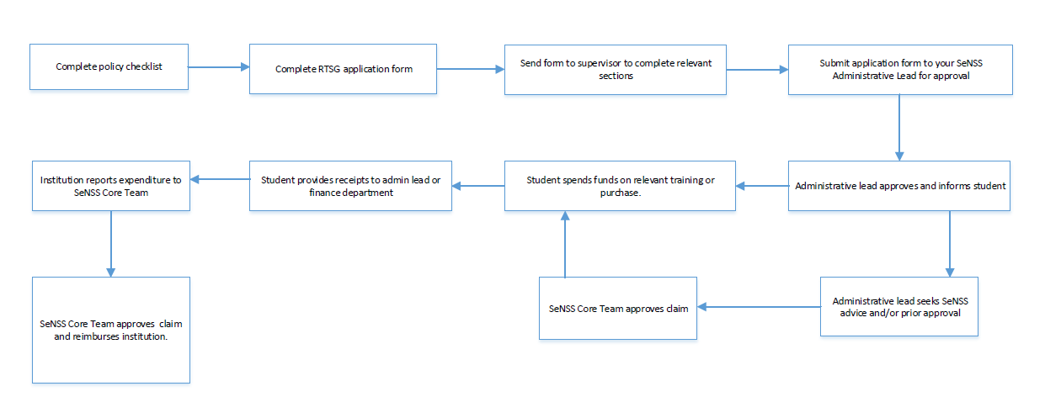
- Will this activity or purchase take place within your funded award period?

