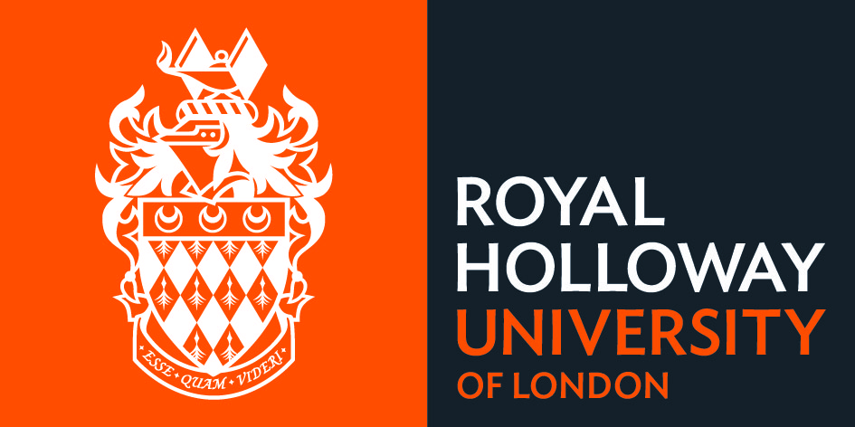

Phase 2 COVID-19 Extension to deadline request form
GUIDANCE NOTES

Please read the following guidance before completing the form

Who should complete this form?

You should complete this form if:
- your current upgrade, thesis submission, dissertation submission, corrections or resubmission deadline is within the next 12 months
AND
- the progress on your research has been adversely affected by Covid-19
AND
- you are only requesting an extension to either your upgrade, submission, corrections or resubmission deadline.
Please complete this form in consultation with your supervisor.

Fees
There will be no extension fee charged for Covid-19 related requests.

Students holding Student Route or Tier-4 Student visas
For the most up to date Government guidance for UK visa holders please visit their webpages - gov.uk/guidance/coronavirus-covid-19-advice-for-uk-visa-applicants-and-temporary-uk-residents. If an extension is granted which takes your period of study beyond your Student Route/Tier 4 visa end date, you may be eligible to apply for a new Confirmation of Acceptance for Studies (CAS) to renew your student visa. However, this is not guaranteed as it will be dependent on your eligibility for further Student Route/Tier 4 leave. Where it is not possible to issue you with another CAS you will be required to complete your studies in your home country. If you later require to return to the UK for your viva you will need to obtain a short-term study visa.
If you are on an ATAS bearing course you must seek a new certificate prior to making an application for an extension (other than to your upgrade deadline) to prevent your visa becoming invalid. For further immigration advice please contact the International Student Support Office at internationaladvice@royalholloway.ac.uk.

Process
- Section 1 should be completed by the postgraduate research student;
The maximum period that can be requested is 6 months
- Once completed, the form should be forwarded to your supervisor for approval;
- The supervisor completes section 2 to confirm their support for the request, including their statement;
- The completed form and any evidence is forwarded to doctoralschool@royalholloway.ac.uk;
- The request is sent to the School Director of PGR Education for approval;
All previous extensions granted due to Covid-19 will be taken into consideration when making a decision
All evidence submitted and mitigation strategies employed will be considered when making a decision
- The student and supervisor are informed of the outcome by the Doctoral School and the student’s record is updated accordingly.

In submitting this form, you give consent for the information contained herein to be shared with the following:
Doctoral School Administrative staff, School Director of PGR Education, Student Administration and the International Student Support Office (if holding a Student Route or Tier 4 visa). If there are wellbeing concerns raised then we will ask our Wellbeing team to contact you with further support if needed. The specific details of any circumstances will not be disclosed.

Phase 2 COVID-19 Extension to deadline request form

Please read the attached guidance before completing the form

Please complete this form in consultation with your supervisor if your current upgrade, dissertation, thesis submission or corrections/re-submission deadline is within the next 12 months, AND your research has been adversely affected by Covid-19.

If you are externally funded and seeking an extension to your submission deadline, you should check with your external organisation or Government that they agree to the extension prior to submitting your application.

Section 1: To be completed by the student
Student name | Click here and type
Student ID number | Click here and type
Programme of study | Click here and type
Extension sought for: | Please check ONE of the following options:  Upgrade  Submission  Corrections/resubmission
Current deadline | Click here and type
Name of supervisor | Click here and type
Duration of extension being requested | Please check ONE of the following options:  1 month 4 months  2 months 5 months  3 months 6 months (max)
Previous Covid-19 extensions granted | Please provide details of any previous Covid-19 extensions granted, including blanket 12 week extensions:  Click here and type
Circumstances Leading to this application. | Please check appropriate box(es):  - lack access to research resources and facilities  - interruption of data collection and/or fieldwork  - increased caring responsibilities  - health and wellbeing affected  - other – specify in the next section
Please provide a brief explanation of how Covid-19 has impacted your studies / your reasons for requesting this extension (300 words maximum). You will need to include a comment on one or more of the grounds listed above. Please include evidence of the mitigation strategies put in place (if any) and the reasons that these strategies have not worked effectively. Personal and sensitive data will be treated in confidence.

Click here and type

Evidence  You should provide evidence to support your application where this is available | Please check the box if you have attached evidence with this application:  Evidence attached?  If you are not able to provide this, please state why this has not been possible:  Click here and type
5. Student signature
- I confirm that I have read the guidance attached and that the information provided above is correct
- I acknowledge that the decision of the College regarding this extension request is final and not open to appeal
- Student Route/Tier 4 visa holders - I understand that it is not guaranteed that I will be issued with a new CAS to extend my leave in the UK
- I confirm that I have checked that my funding body permits this extension (for extensions to submission deadline only)

Please type your name here in order to sign this form: Click here and type

Date of signature: Click here and type

Please forward the completed form and your evidence to your supervisor for their approval

Section 2: Supervisor’s statement & approval
Supervisor statement

Please provide a statement of support that explains the mitigation strategies that your student has taken and why they have not worked (300 words maximum).

Click here and type

Supervisor approval
- I support the request above for an extension to the upgrade/submission/corrections deadline
- I confirm that the duration of the extension requested is appropriate
- I confirm that if appropriate and feasible, the candidate has taken all reasonable steps to mitigate against the impact Covid-19 has had on their progress
- I confirm that if there is an external partner organisation involved in funding the student, they have agreed to this extension, and I have attached confirmation of this

Please type your name here in order to sign this form: Click here and type

Date of signature: Click here and type

The supervisor, or nominated academic, should now email this form and any evidence provided to doctoralschool@royalholloway.ac.uk.

The email will be accepted in lieu of a physical signature from the supervisor.

