Accessing Senate House e-journals
In order to access Senate House’s e-journals, you need a Senate House library barcode. In order to get one of these, you can go to Senate House in person, bringing your College card, and they will make a membership card for you. Alternatively you can register remotely using the online form:
https://ezproxy01.rhul.ac.uk/login?url=https://ezproxy01.rhul.ac.uk/loggedin/senatehouse.htm
Enter your Royal Holloway login name & password (the same login you use to access the College network & email service). This will lead you to an online form. Complete the form, and Senate House will send a barcode number to your Royal Holloway email address. You can now access e-journals remotely.
Go to the home page of Senate House:
http://www.ull.ac.uk/
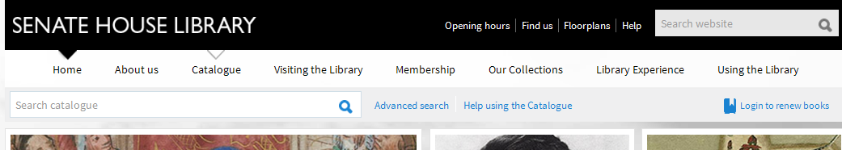
You’re looking for a specific journal, so you don’t want to do a general keyword search. Instead, click on ‘Advanced search’.
2
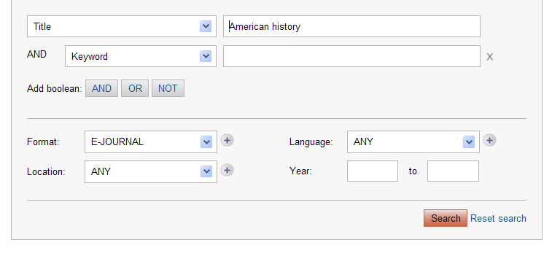
1
3
Select ‘Title’ from the first drop down menu (1), then type the name of the journal in the box (2). For this example we are using the journal American History.
From the ‘Format’ drop down menu, select E-JOURNAL (3) and click on ‘Search’.

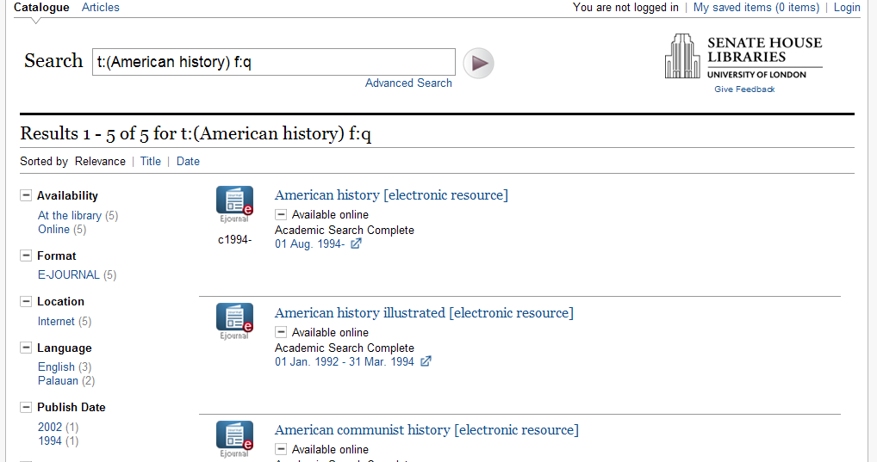Cli
Click on the blue link to the journal American history, and you’ll get the journal screen:
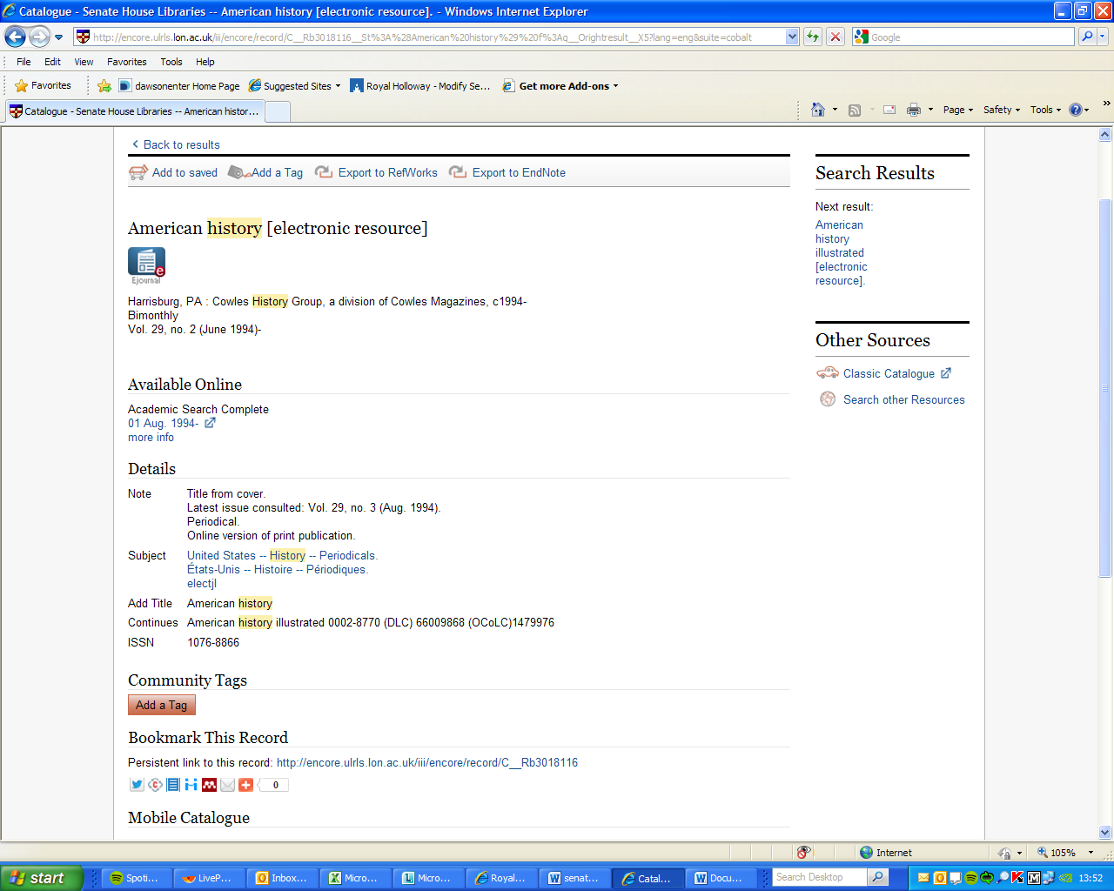
As you can see from the screen above, this gives us web access from 1994 onwards. Underneath the text “Available Online”, click on the link to the relevant database or publisher. In this case you need to click on the date under Academic Search Complete. Sometimes there are two different entries which provide you with different year ranges, but in this case there is only one link to select.

You then get to the Senate House login screen:
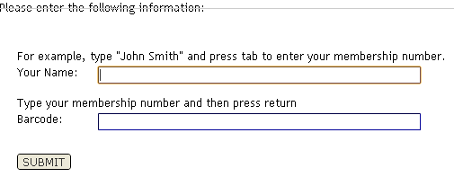
Enter your name (as it appears on the membership card) or as you yourself entered when you registered – normally just first name last name e.g. John Smith.
Enter your membership number (as it appears on the membership card or alternatively the number you were sent when you registered remotely – this is typically a 7-digit number).
Click Submit.
You will then be taken to the home page of the journal you have chosen, and at this point you can choose the year and journal issue you need, or do a search within the journal, in exactly the same way as you would for a journal you have accessed via Royal Holloway.

