FRAMEWORK FOR THE IMPLEMENTATION OF THE
2021 INTELLECTUAL PROPERTY AND COMMERCIAL PARTNERING POLICY
Contents:
1. Introduction page 3
2. Ownership of IP page 4
2.1 Ownership of IP created by an Employee page 5
2.2 Ownership of IP created by a Postgraduate Student page 8
2.3 Ownership of IP created by a Supplier page 10
2.4 Ownership of IP created by an Academic Visitor page 11
2.5 Ownership of IP created by an Undergraduate Student page 12
2.6 Ownership of IP created by a University of London Student page 13
3. Classes of IP page 14
3.1 Artistic Material page 14
3.2 Scholarly Material page 15
3.3 Teaching Material page 15
3.4 University Material page 16
4. General requirements page 17
4.1 Responsibility for University IP page 17
4.2 Responsibility for IP other than University IP page 18
4.3 Obligation to acknowledge Third Party IP and University IP page 19
4.4 Obligation to disclose potential infringement of IP or opposition to IP page 19
4.5 Obligation to disclose potential conflict of interest page 19
4.6 Obligation to maintain confidentiality, publication approval processes, and thesis on restricted access page 20
4.7 Obligation to notify potentially Commercialisable University IP page 21
4.8 The University’s Position on Guarantee, Pipelines, Repayments, and Warranties page 21
4.9 Completion of formalities page 21
4.10 Obligation to deposit University IP and Scholarly Material page 21
4.11 Grant of Performer’s Rights Licence to the University page 22
5. Release of University IP page 22
5.1 Release of University IP for Non-Commercial Use page 23
5.2 Release of University IP for Commercial Use - Commercial Partnering Arrangements page 24
6. IP Management page 25
6.1 Departments that assist with the management of University IP page 25
6.2 The Commercial Partnering Panel’s role page 26
6.3 Commercial Partnering Arrangement with an existing Third Party under a Pull Scenario page 27
6.4 Commercial Partnering Arrangement with an existing Third Party under a Push Scenario page 27
6.5 Commercial Partnering Arrangement with the Originator(s) to allow the Originator(s) to form a Self-Commercialisation Company page 28
6.6 Commercial Partnering Arrangement with the Originator(s) to form a Spin-Out Company page 30
6.7 Originator Assistance and Obligations page 31
6.8 Possible Assignment University IP to the Funder, a Technology Transfer Organisation, or the Originator(s) page 31
6.9 Use of University’s name page 32
6.10 Social Responsibility page 32
6.11 Timetable for setting up a Commercial Partnering Arrangement page 32
6.12 Monitoring of Commercial Partnering Arrangements page 32
6.13 Protection of University IP - potentially patentable invention page 33
6.14 Protection of University IP - trade mark page 34
6.15 Protection of University IP - other forms of Protection page 35
6.16 Share of Net Income page 35
6.17 Exception Procedure page 36
7. Dispute Procedure page 36

Schedules:
A. Glossary page 38
B. Authorship, ownership and acknowledgement of a copyright protected work page 45
C. Release of a copyright protected work (other than software) which is University IP under a Creative Commons licence page 48
D. Release of software which is University IP under an Open Source licence page 51
E. Managing a copyright protected work which is not University IP page 53
F. Standard Commercial Partnering Arrangements page 54
G. Confidential Circle page 61
H. The University’s Position on Guarantees, Pipelines, Repayments, and Warranties page 62
I. Detailed provisions about the sharing of Net Income page 64
J. The University’s Position on Non-Commercial Partnering Arrangements page 71

1. INTRODUCTION
1.1 UK government and UK funders are increasingly requiring UK universities to engage with real world challenges and to make their research outputs available to benefit society. The requires each UK university to consider which research outputs (=IP) its employee and students create and how the UK university is managing these research outputs. Diagram 1 highlights the different types of research outputs that a UK university will typically create.
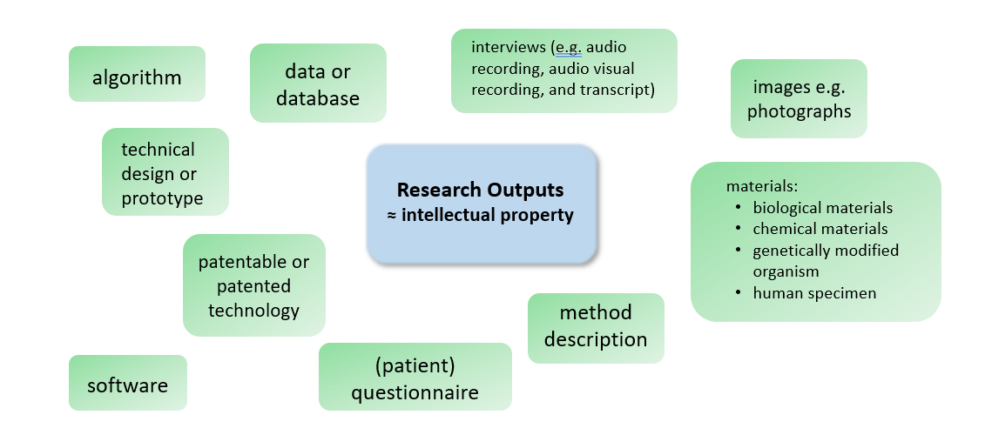
Diagram 1: an overview of different types of research outputs / IP
1.2 The University has an IP Policy which sets out i) whether or not the University owns or does not own certain IP which individuals associated with the University create, ii) why the University is obliged, where possible, to allow a third party to Commercialise University IP via a Commercial Partnering Arrangement, and iii) clarify that all individuals associated with the University need to reduce the chances that Third Party IP is not infringed.
1.3 This Framework provides a detailed record of how the IP Policy is implemented, for example, by requiring Employees to take certain steps before allowing an Undergraduate Student to contribute to a University Project.
1.4 To keep this Framework simple, it has been written as if the relevant IP has been created by one individual. In reality IP is usually created by more than one individual and is, as a result, often co-owned. If this situation applies then any reference to “ownership” of IP in this Framework must be read as “ownership of a share” of the IP.
1.5 This Framework also sets out the University’s approach to the Protection of University IP and how the University will share the financial rewards it receives from any Commercial Partnering Arrangement.
1.6 When reading this Framework, it is important to take note of Schedule A (Glossary) as capitalised terms used in this Framework are defined there, unless otherwise specified.
1.7 This Framework is effective from 1st January 2021.
1.8 This Framework is a living document and may be subject to change by the Innovation and Enterprise Working Group.
1.9 If any individual associated with the University (whether he or she is an Employee, Postgraduate Student, Academic Visitor, Undergraduate Student, University of London Student, or otherwise) has any question on the interpretation, or current status, of this Framework he or she may address this question to the Director of Research and Innovation.
1.10 If any individual associated with the University (whether he or she is Employee, Postgraduate Student, Academic Visitor, Undergraduate Student, University of London Student, or otherwise) has any question about who owns (or co-owns) any particular IP he or she may address this question to the Director of Research and Innovation. If individual associated with the University (whether he or she is the Employee, Postgraduate Student, Academic Visitor, Undergraduate Student, University of London Student, or otherwise) disagrees with the Director of Research and Innovation’s decision, then the matter shall be dealt with in accordance with section 7 (Dispute Procedure).
1.11 Questions about any IP which was created by individual associated with the University (whether he or she was an Employee, a Postgraduate Student, an Academic Visitor, an Undergraduate Student, University of London Student, or otherwise) whether alone or together with any other Employee, Postgraduate Student, Academic Visitor, Undergraduate Student, University of London Student, or a Third Party at before this Framework applied will be dealt with by the Director of Research and Innovation on a case-by-case basis. If the individual associated with the University (whether he or she is Employee, Postgraduate Student, Academic Visitor, Undergraduate Student, University of London Student, or otherwise) disagrees with the Director of Research and Innovation’s decision, then the matter shall be dealt with in accordance with section 7 (Dispute Procedure).

2. OWNERSHIP OF IP
A key aspect of IP management is understanding who own which research outputs / IP.
Diagram 2 shows that as a rule the University will own the research outputs / IP created by an Employee, a Postgraduate Student or a Supplier. Sections 2.1 to 2.3 explain the ownership of research outputs / IP created by an Employee, a Postgraduate Student or a Supplier in detail.

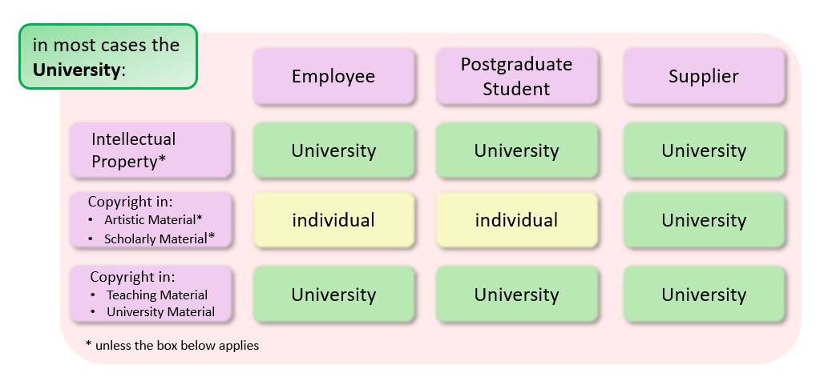
Diagram 2: ownership of research outputs / IP created by an Employee, Postgraduate Student or Supplier
Diagram 3 shows that as a rule the individual will own the research outputs / IP created by an Academic Visitor, an Undergraduate Student or a University of London Student. Sections 2.4 to 2.6 explain the ownership of research outputs / IP created by an Academic Visitor, an Undergraduate Student or a University of London Student in detail.
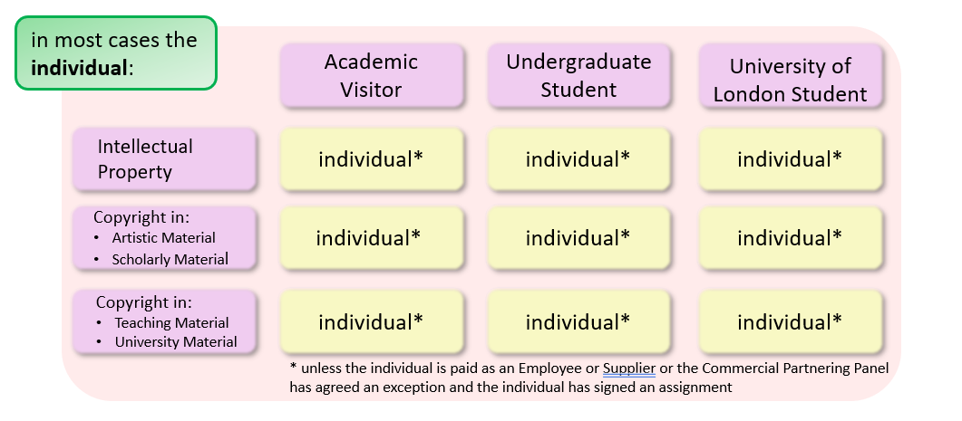
Diagram 3: ownership of research outputs / IP created by an Academic Visitor, an Undergraduate Student or a University of London Student
2.1 Ownership of IP created by an Employee
2.1.1 Save as set out in section 2.1.2, IP created by an Employee (including a Postgraduate Student, an Academic Visitor, an Undergraduate Student, or a University of London Student where he or she is also an Employee) will belong to the University as follows:
2.1.1.1 as a matter of law, rights in IP created by an Employee in the course of his or her employment or duties will automatically belong to the University;
2.1.1.2 if an Employee creates IP outside the course of his or her employment or duties, with more than Incidental Use of University Resources, then, by doing so, he or she agrees to assign such IP to the University and will do so upon the University’s request; and
2.1.1.3 if an Employee creates IP in the course of, or pursuant to, a research agreement or other agreement with a Third Party, such IP will initially belong to the University and then, depending on the terms of the relevant agreement, to the University or the Third Party.
2.1.2 The University will not usually own:
2.1.2.1 IP created by an Employee outside the course of his or her employment or duties; or
2.1.2.2 copyright in an Artistic Material or a Scholarly Material (see section 3.1 and section 3.2, respectively, of this Framework for further details).
2.1.3 No formal assignment of University IP from the Employee to the University is generally required as the assignment takes place through statutory provision. Nonetheless, the University may require an Employee to sign a confirmatory assignment for any University IP he or she created and, if necessary, a separate assignment for any territory where it is not possible to assign future IP.
2.1.4 Each Employee acknowledges that the provisions of sections 4 to 6 (which include the obligation to disclose Commercialisable University IP) apply to University IP.
2.1.5 If an Employee is unsure whether any IP he or she has created is University IP, the Employee must assume that it does and make a disclosure to the University. This includes an Employee who is employed by the University on a part-time basis needing to i) disclose IP which is potentially commercial value to the University even if the Employee believes that the IP does not belong to the University, and ii) follow the exceptions process set out in section 6.16 (Exception Procedure) to ask the University to clarify whether or not the IP is University IP. For the avoidance of doubt, the Employee must have followed the process set out in section 6.16 (Exception Procedure) before filing (or allowing to be filed) a patent application which covers IP created by the Employee or any Postgraduate Student, Academic Visitor, Undergraduate Student, or University of London Student the Employee is responsible for and failure to do so may be a disciplinary offence.
2.1.6 If an Employee disputes that certain University IP belongs to the University in accordance with section 2.1.1 or if an Employee does not assign his or her rights in University IP to the University in accordance with section 2.1.3, then the University may, amongst other things:
2.1.6.1 withdraw the Employee from the project or research programme; or
2.1.6.2 request that the Employees ceases to use University Resources outside the course of his or her employment or duties.
2.1.7 An Employee may need to work at home or at a Third Party’s premises as part of his/her regular duties. Where this is the case, this is referred to as “working away” (rather than a secondment) for the purpose of the Framework and sections 2.1.1 to 2.1.6 apply in the same way as if the Employee were working at the University’s premises.
2.1.8 An Employee may be asked to become an academic visitor with a Third Party. The default IP arrangement where an Employee is an academic visitor with a Third Party is that the University owns the IP created by the Employee whilst he or she is an academic visitor with the Third Party. For the avoidance of doubt, “academic visitor” in the context of this section means any situation where an Employee visits a Third Party for more than five working days other than as set out under section 2.1.7 (honorary academic appointment) or under section 2.1.8 (secondment). Before an Employee becomes an academic visitor with a Third Party, the Employee shall ask his or her Authoriser for permission indicating whether or not the default IP arrangement will apply. In the event that the Employee or the Third Party request that the non-standard IP arrangement (i.e. the Third Party will own the IP which the Employee creates whilst he or she is an academic visitor) applies, the Employee shall also explain to his or her Authoriser why the non-default IP arrangement is fair. If the Authoriser agrees that the Employee may assume such a role and the proposed IP arrangement is appropriate, the Authoriser shall confirm this to the Employee. The Employee shall then ensure that he or she has an email from the Third Party confirming the IP arrangement. In the event that the Third Party insists that an academic visitor agreement is signed this will need to be signed by the Head of Department who will need to check whether a legal review by Legal Services is required under the Contracts Legal Review Process.
2.1.9 An Employee may be offered an honorary academic appointment with a Third Party. The default IP arrangement where an Employee has an honorary academic appointment with a Third Party is that the University owns the IP created by the Employee whilst he or she acts under his or her honorary academic appointment with the Third Party. Before an Employee accepts an honorary appointment, the Employee shall ask his or her Authoriser for permission indicating whether or not the default IP arrangement will apply. In the event that the Employee or the Third Party requests that the non-standard IP arrangement (i.e. the Third Party will own the IP which the Employee creates whilst he or she acts under the honorary appointment) applies, the Employee shall also explain to his or her Authoriser why the non-default IP arrangement is fair. If the Authoriser agrees that the Employee may accept the honorary academic appointment and the proposed IP arrangement is appropriate, the Authoriser shall confirm this to the Employee. The Employee shall then ensure that he or she has an email from the Third Party confirming the IP arrangement. In the event that the Third Party insists that an agreement confirming the honorary academic appointment is signed this will need to be signed by the Head of Department who will need to check whether a legal review by Legal Services is required under the Contracts Legal Review Process.
2.1.10 An Employee may be asked to become seconded to a Third Party so that the Employee would in practise work for the Third Party for a fixed period or percentage of time in return for the Third Party reimbursing a portion of the Employee’s salary to the University. The default IP arrangement where an Employee is seconded to a Third Party, is that the Third Party owns the IP which the Employee creates during the secondment. Before an Employee becomes seconded, the Employee shall ask his or her Authoriser for permission indicating whether or not the default IP arrangement will apply. In the event that the Employee or the Third Party request that the non-standard IP arrangement (i.e. the University will own the IP which the Employee creates whilst he or she is seconded) applies, the Employee shall also explain to his or her Authoriser why the non-default IP arrangement is fair. If the Authoriser agrees that the Employee may assume such a role and the proposed IP arrangement is appropriate, the Authoriser shall confirm this to the Employee and Human Resources together with an indication of the proposed IP ownership regime. Human Resources shall then ensure that an agreement is put in place, between the University and the Third Party to define (amongst other things) who will own the IP created by the Employee whilst he or she is seconded to the Third Party.
2.1.11 An Employee must sign any document that the University reasonably requests the Employee to sign to ensure that rights in University IP, as set out in this Framework, either remain with, or are assigned to, the University.
2.1.12 In the event that another Employee, a Postgraduate Student, or an Academic Visitor wishes an Employee to assign any IP the Employee creates (whether this is University IP or otherwise) to another Employee, Postgraduate Student, Academic Visitor, or any third party, the relevant Employee, Postgraduate Student, or Academic Visitor must follow the process set out in section 6.16 (Exception Procedure). Failure to follow this process may be a disciplinary offence on the part of the party wishing to take assignment of the relevant IP.
2.2 Ownership of IP created by a Postgraduate Student
2.2.1 Save as set out in section 2.2.2, IP created by a Postgraduate Student will belong to the University as follows:
2.2.1.1 rights in IP created by a Postgraduate Student in the course of his or her postgraduate studies will belong to the University;
2.2.1.2 if a Postgraduate Student creates IP outside the course of his or her postgraduate studies, with more than Incidental Use of University Resources, then, by doing so, he or she agrees to assign such IP to the University and will do so upon the University’s request; and
2.2.1.3 if a Postgraduate Student creates IP in the course of, or pursuant to, a research agreement or other agreement with a Third Party, such IP will initially belong to the University and then, depending on the terms of the relevant agreement, to the University or the Third Party.
2.2.2 The University will not usually own:
2.2.2.1 IP created by a Postgraduate Student outside the course of his or her postgraduate studies; or
2.2.2.2 copyright in an Artistic Material or a Scholarly Material (see section 3.1 and section 3.2, respectively, of this Framework for further details).
2.2.3 The University requires each Postgraduate Student to assign the IP he or she will create in the course of his or her postgraduate studies upon enrolment to the University. In addition, the University may require a Postgraduate Student to sign a confirmatory assignment for any University IP he or she created and, if necessary, a separate assignment for any territory where it is not possible to assign future IP.
2.2.4 Each Postgraduate Student acknowledges that the provisions of sections 4 to 7 (which include the obligation to disclose Commercialisable University IP) apply to University IP.
2.2.5 If a Postgraduate Student is unsure whether any IP he or she has created is University IP, the Postgraduate Student must assume that it does and make a disclosure to the University. This includes a Post-Graduate who works part-time for another party, himself or herself needing to i) disclose IP which is potentially commercial value to the University even if the Post-Graduate Student believe that the IP does not belong to the University, and ii) follow the exceptions process set out in section 6.16 (Exception Procedure) to ask the University to clarify whether or not the IP is University IP. For the avoidance of doubt, the Postgraduate Student must have followed the process set out in section 6.16 (Exception Procedure) before filing (or allowing to be filed) a patent application which covers IP created by the Postgraduate Student and failure to do so may be a disciplinary offence.
2.2.6 If a Postgraduate Student does not assign his or her rights in University IP to the University in accordance with section 2.2.3, then the University may, amongst other things:
2.2.6.1 withdraw the Postgraduate Student from the project or research programme (whether this is a (co-)funded studentship or otherwise); or
2.2.6.2 request that the Postgraduate Student ceases to use University Resources outside the course of his or her postgraduate studies.
2.2.7 A Postgraduate Student may need to work at home or at a Third Party’s premises as part of his/her studies. Where this is the case, this is referred to as “working away” (rather than a placement) for the purpose of the Framework and sections 2.2.1 to 2.2.6 apply in the same way as if the Postgraduate Student was carrying out his/her studies at the University’s premises.
2.2.8 A Postgraduate Student may be asked to become an academic visitor with a Third Party. The default IP arrangement where a Postgraduate Student is an academic visitor with a Third Party is that the University owns the IP created by the Postgraduate Student whilst he or she is an academic visitor with the Third Party. For the avoidance of doubt, “academic visitor” in the context of this section means any situation where a Postgraduate Student visits a Third Party for more than five working days other than as set out under section 2.2.7 (honorary academic appointment) or under section 2.2.8 (placement). Before a Postgraduate Student becomes an academic visitor with a Third Party, the Postgraduate Student shall ask his or her Academic Supervisor for permission indicating whether or not the default IP arrangement will apply. In the event that the Postgraduate Student or the Third Party request that the non-standard IP arrangement (i.e. the Third Party will own the IP which the Postgraduate Student creates whilst he or she is an academic visitor) applies, the Postgraduate Student shall also explain to his or her Academic Supervisor why the non-default IP arrangement is fair. If the Academic Supervisor agrees that the Postgraduate Student may assume such a role and the proposed IP arrangement is appropriate, the Academic Supervisor shall confirm this to the Postgraduate Student and the Doctoral School. The Postgraduate Student shall then ensure that he or she has an email from the Third Party confirming the IP arrangement. In the event that the Third Party insists that an academic visitor agreement is signed this will need to be signed by the Head of Department who will need to check whether a legal review by Legal Services is required under the Contracts Legal Review Process.
2.2.9 A Postgraduate Student may be offered an honorary academic appointment with a Third Party. The default IP arrangement where a Postgraduate Student has an honorary academic appointment with a Third Party is that the University owns the IP created by the Postgraduate Student whilst he or she acts under his or her honorary academic appointment with the Third Party. Before an Postgraduate Student accepts an honorary appointment, the Postgraduate Student shall ask his or her Academic Supervisor for permission indicating whether or not the default IP arrangement will apply. In the event that the Postgraduate Student or the Third Party requests that the non-standard IP arrangement (i.e. the Third Party will own the IP which the Postgraduate Student creates whilst he or she acts under the honorary appointment) applies, the Postgraduate Student shall also explain to his or her Academic Supervisor why the non-default IP arrangement is fair. If the Academic Supervisor agrees that the Postgraduate Student may accept the honorary academic appointment and the proposed IP arrangement is appropriate, the Academic Supervisor shall confirm this to the Postgraduate Student. The Postgraduate Student shall then ensure that he or she has an email from the Third Party confirming the IP arrangement. In the event that the Third Party insists that an agreement confirming the honorary academic appointment is signed this will need to be signed by the Head of Department who will need to check whether a legal review by Legal Services is required under the Contracts Legal Review Process.
2.2.10 A Postgraduate Student may be asked to have a placement with a Third Party. The default IP arrangement where a Postgraduate Student has a placement with a Third Party, is that the University owns the IP which the Postgraduate Student creates during the placement. Before a Postgraduate Student accepts the placement, the Postgraduate Student shall ask his or her Academic Supervisor for permission indicating whether or not the default IP arrangement will apply. In the event that the Postgraduate Student or the Third Party request that the non-standard IP arrangement (i.e. the Third Party will own the IP which the Postgraduate Student creates during the placement) applies, the Postgraduate Student shall also explain to his or her Academic Supervisor why the non-default IP arrangement is fair. If the Academic Supervisor agrees that the Postgraduate Student accept the placement and the proposed IP arrangement is appropriate, the Academic Supervisor shall confirm this to the Postgraduate Student and the Doctoral School together with an indication of the proposed IP ownership regime. The Doctoral School shall then ensure that an agreement is put in place, between the University and the Third Party to define (amongst other things) who will own the IP created by the Postgraduate Student during the placement with the Third Party.
2.2.11 A Postgraduate Student must sign any document that the University reasonably requests the Postgraduate Student to sign to ensure that rights in University IP, as set out in this Framework, either remain with, or are assigned to, the University.
2.2.12 In the event that an Employee, another Postgraduate Student, or an Academic Visitor wishes a Postgraduate Student to assign any IP the Postgraduate Student creates (whether this is University IP or otherwise) to an Employee, Postgraduate Student, Academic Visitor, or any third party, the relevant Employee, Postgraduate Student, or Academic Visitor must follow the process set out in section 6.16 (Exception Procedure). Failure to follow this process may be a disciplinary offence on the part of the party wishing to take assignment of the relevant IP.
2.3 Ownership of IP created by a Supplier
2.3.1 Save as set out in section 2.3.2, it is the expectation of the University and the Funder, if any, that any IP created by a Supplier will belong to the University. Suppliers are normally paid via a purchase order which refers to the University’s standard purchase order terms.
2.3.2 In the event that an Employee, a Postgraduate Student, or Academic Visitor believes that the Supplier (rather than the University) should own any IP which the Supplier will create, the relevant Employee, Postgraduate Student, or Academic Visitor must follow the process set out in section 6.16 (Exception Procedure).
2.3.3 In the event that an Employee, a Postgraduate Student, or Academic Visitor wishes a Supplier to assign any IP the Supplier creates (whether this is University IP or otherwise) to an Employee, Postgraduate Student, Academic Visitor, or any third party, the relevant Employee, Postgraduate Student, or Academic Visitor must follow the process set out in section 6.16 (Exception Procedure). Failure to follow this process may be a disciplinary offence on the part of the party wishing to take assignment of the relevant IP.
2.4 Ownership of IP created by an Academic Visitor
2.4.1 Save as set out in sections 2.4.2 and 2.4.3, an Academic Visitor (or his or her employer) will own the IP that he or she creates whilst he or she is an Academic Visitor.
2.4.2 If an Academic Visitor is also an Employee (whether part time or otherwise), any IP he or she creates as an Employee is subject to section 2.1 of this Framework.
2.4.3 Additionally, IP created by an Academic Visitor whilst he or she is an Academic Visitor will belong to the University if the Host (as set out in section 2.4.4) allows:
2.4.3.1 the Academic Visitor to participate in a University Project; or
2.4.3.2 the Academic Visitor to contribute to, create, or use any Teaching Material or University Material.
2.4.4 Each Academic Visitor must have a Host and the Host shall inform his or her Authoriser before he or she offers to host an individual as an Academic Visitor setting out whether section 2.4.3.1 or section 2.4.3.2 will apply. If the Authoriser agrees that it is appropriate for the individual to be an Academic Visitor, and, if relevant, for sections 2.4.3.1 and 2.4.3.2 to apply, the Authoriser shall confirm this to the Host and to Human Resources. Human Resources shall then ensure that an agreement is put in place between the University and the individual or the Third Party who employs the individual to define (amongst other things) who will own any IP created by the Academic Visitor during his or her visit.
2.4.5 For the avoidance of doubt, no Postgraduate Student or Academic Visitor may host an Academic Visitor.
2.4.6 If a circumstance set out in sections 2.4.3.1 or 2.4.3.2 applies, the University requires each affected Academic Visitor to assign the IP he or she will create as a result of the acts set out in section 2.4.3 to the University. In addition, the University may require the Academic Visitor to sign a confirmatory assignment for any University IP he or she created and, if necessary, a separate assignment for any territory where it is not possible to assign future IP.
2.4.7 Each Academic Visitor acknowledges that the provisions of sections 4 to 7 (which include the obligation to disclose Commercialisable University IP) apply to University IP. If an Academic Visitor is unsure whether any IP he or she has created is University IP, the Academic Visitor should discuss this with his or her Host.
2.4.8 If a circumstance set out in sections 2.4.3.1 or 2.4.3.2 applies and the affected Academic Visitor does not assign his or her rights in University IP to the University in accordance with section 2.4.6, then the University may, amongst other things:
2.4.8.1 withdraw the Academic Visitor from the University Project; or
2.4.8.2 request that the Academic Visitor ceases to contribute to, create, or use any Teaching Material or University Material.
2.4.9 In the event that an Employee, a Postgraduate Student, or another Academic Visitor wishes an Academic Visitor to assign any IP the Academic Visitor creates (whether this is University IP or otherwise) to an Employee, Postgraduate Student, Academic Visitor, or any third party, the relevant Employee, Postgraduate Student, or Academic Visitor must follow the process set out in section 6.16 (Exception Procedure). Failure to follow this process may be a disciplinary offence on the part of the party wishing to take assignment of the relevant IP.
2.5 Ownership of IP created by an Undergraduate Student
2.5.1 Save as set out in sections 2.5.2 and 2.5.3, an Undergraduate Student will own the IP that he or she creates whilst he or she is an Undergraduate Student. This includes the IP which an Undergraduate Student creates in his or her final year project unless any of the circumstances as set out in section 2.5.3 apply.
2.5.2 If an Undergraduate Student is also an Employee (whether part time or otherwise), any IP he or she creates as an Employee is subject to section 2.1 of this Framework.
2.5.3 Additionally, IP created by an Undergraduate Student whilst he or she is an Undergraduate Student will belong to the University if an Employee allows:
2.5.3.1 the Undergraduate Student to participate in a University Project; or
2.5.3.2 the Undergraduate Student to contribute to, create, or use any Teaching Material or University Material.
2.5.4 If the circumstances set out in sections 2.5.3.1 or 2.5.3.2 apply, the Employee shall
2.5.4.1 inform the Undergraduate Student about the need for him or her to assign the IP before the Undergraduate Student starts any work; and
2.5.4.2 ask Research Contracts to put the necessary agreement in place to ensure that the IP which the Undergraduate Student will create is assigned to the University.
2.5.5 For the avoidance of doubt, no Postgraduate Student or Academic Visitor may allow an Undergraduate Student to carry out the acts set out in section 2.5.3.
2.5.6 If a circumstance set out in sections 2.5.3.1 or 2.5.3.2 applies, the University requires each affected Undergraduate Student to assign the IP he or she will create as a result of the acts set out in section 2.5.3 to the University. In addition, the University may require the Undergraduate Student to sign a confirmatory assignment for any University IP he or she created and, if necessary, a separate assignment for any territory where it is not possible to assign future IP.
2.5.7 Each Undergraduate Student acknowledges that the provisions of sections 4 to 7 (which include the obligation to disclose Commercialisable University IP) apply to University IP. If an Undergraduate Student is unsure whether any IP he or she has created is University IP, the Undergraduate Student must discuss this with the Employee who allowed the Undergraduate Student to carry out an act set out in section 2.5.3.1 or 2.5.3.2.
2.5.8 If a circumstance set out in sections 2.5.3.1 or 2.5.3.2 applies and the affected Undergraduate Student does not assign his or her rights in University IP to the University in accordance with section 2.5.6, then the University may, amongst other things:
2.5.8.1 withdraw the Undergraduate Student from the University Project; or
2.5.8.2 request that the Undergraduate Student ceases to contribute to, create, or use any Teaching Material or University Material.
2.5.9 Each Undergraduate Student grants to the University an irrevocable, non-exclusive, royalty- free, worldwide licence, with the right to sub-license, to use his or her Undergraduate Student IP which was created in the course of the Undergraduate Student’s studies for administrative, promotional, and teaching purposes upon creation of the relevant IP and for as long as the relevant IP remains in existence.
2.5.10 In the event that an Employee, a Postgraduate Student, or an Academic Visitor wishes an Undergraduate Student to assign any IP the Undergraduate Student creates (whether this is University IP or otherwise) to another Employee, Postgraduate Student, Academic Visitor, or any third party, the relevant Employee, Postgraduate Student, or Academic Visitor must follow the process set out in section 6.16 (Exception Procedure). Failure to follow this process may be a disciplinary offence on the part of the party wishing to take assignment of the relevant IP.
2.6 Ownership of IP created by a University of London Student
2.6.1 Save as set out in sections 2.6.2 and 2.6.3, a University of London Student (or in many case his/her employer if his/her employer is funding the University of London Student) will own the IP that he or she creates whilst he or she is a University of London Student. This includes the IP which a University of London Student creates in his or her research project unless any of the circumstances as set out in section 2.6.3 apply.
2.6.2 If a University of London Student is also an Employee (whether part time or otherwise), any IP he or she creates as an Employee is subject to section 2.1 of this Framework.
2.6.3 Additionally, IP created by a University of London Student whilst he or she is a University of London Student will belong to the University if an Employee allows:
2.6.3.1 the University of London Student to participate in a University Project; or
2.6.3.2 the University of London Student to contribute to, create, or use any Teaching Material or University Material.
2.6.4 If the circumstances set out in sections 2.6.3.1 or 2.6.3.2 apply, the Employee shall
2.6.4.1 inform the University of London Student about the need for him or her to assign the IP before the University of London Student starts any work; and
2.6.4.2 ask Research Contracts to put the necessary agreement in place to ensure that the IP which the University of London Student will create is assigned to the University.
2.6.5 For the avoidance of doubt, no Postgraduate Student or Academic Visitor may allow a University of London Student to carry out the acts set out in section 2.6.3.
2.6.6 If a circumstance set out in sections 2.6.3.1 or 2.6.3.2 applies, the University requires each affected University of London Student to assign the IP he or she will create as a result of the acts set out in section 6.3 to the University. In addition, the University may require the University of London Student to sign a confirmatory assignment for any University IP he or she created and, if necessary, a separate assignment for any territory where it is not possible to assign future IP.
2.6.7 Each University of London Student acknowledges that the provisions of sections 4 to 7 (which include the obligation to disclose Commercialisable University IP) apply to University IP. If a University of London Student is unsure whether any IP he or she has created is University IP, the University of London Student must discuss this with the Employee who allowed the University of London Student to carry out an act set out in section 2.6.3.1 or 2.6.3.2.
2.6.8 If a circumstance set out in sections 2.6.3.1 or 2.6.3.2 applies and the affected University of London Student does not assign his or her rights in University IP to the University in accordance with section 2.5.6, then the University may, amongst other things:
2.6.8.1 withdraw the University of London Student from the University Project; or
2.6.8.2 request that the University of London Student ceases to contribute to, create, or use any Teaching Material or University Material.
2.6.9 Each University of London Student grants to the University an irrevocable, non-exclusive, royalty- free, worldwide licence, with the right to sub-license, to use his or her University of London Student IP which was created in the course of the University of London Student’s studies for administrative, promotional, and teaching purposes upon creation of the relevant IP and for as long as the relevant IP remains in existence.
2.6.10 In the event that an Employee, a Postgraduate Student, or an Academic Visitor wishes a University of London Student to assign any IP the University of London Student creates (whether this is University IP or otherwise) to another Employee, Postgraduate Student, Academic Visitor, or any third party, the relevant Employee, Postgraduate Student, or Academic Visitor must follow the process set out in section 6.16 (Exception Procedure). Failure to follow this process may be a disciplinary offence on the part of the party wishing to take assignment of the relevant IP.

3. CLASSES OF IP
Most IP created at the University will be “regular IP” and the first line in diagrams 2 and 3 at the beginning of section 2 (Ownership of IP) will apply. The ownership of an Artistic Material and Scholarly Material is shown in the second line in diagrams 2 and 3 at the beginning of section 2 and sections 3.1 and 3.2 provide more detail. The ownership of a Teaching Material and University Material is shown in the third line in diagrams 2 and 3 at the beginning of section 2 and sections 3.3 and 3.4 provide more detail.
3.1 Artistic Material
3.1.1 Subject to the relevant Employee or Postgraduate Student complying with the remainder of this section 3.1, the University waives its right to own the copyright in an Artistic Material, which means that the copyright in an Artistic Material is owned by the Employee or Postgraduate Student who created the Artistic Material, except:
3.1.1.1 where such copyright has been created with more than Incidental Use of University Resources;
3.1.1.2 where such copyright has been created in the course of, or pursuant to, a research agreement or other agreement with a Third Party;
3.1.1.3 in relation to any item which is a Teaching Material or a University Material; and
3.1.1.4 where publication of the Artistic Material in question might bring the University into disrepute.
3.1.2 For the avoidance of doubt, the University does not waive any other right the University may have in the Artistic Material.
3.1.3 Each Employee and each Postgraduate Student grants to the University an irrevocable, non-exclusive, royalty- free, worldwide licence, with the right to sub-license, to use the copyright in his or her Artistic Material for administrative, promotional, teaching, and research purposes upon creation of the relevant IP and for as long as the relevant IP remains in existence.
3.2 Scholarly Material
3.2.1 Subject to the relevant Employee or Postgraduate Student complying with the remainder of this section 3.2, the University waives its right to own the copyright in a Scholarly Material, which means that the copyright in a Scholarly Material is owned by the Employee or Postgraduate Student who created the Scholarly Material, except:
3.2.1.1 where such copyright has been created with more than Incidental Use of University Resources;
3.2.1.2 where such copyright has been created in the course of, or pursuant to, a research agreement or other agreement with a Third Party;
3.2.1.3 in relation to any item which is a Teaching Material or a University Material; and
3.2.1.4 where publication of the Scholarly Material in question might bring the University into disrepute.
3.2.2 For the avoidance of doubt, the University does not waive any other right the University may have in the Scholarly Material. For example, if an Employee writes a journal article which includes data or a questionnaire, the copyright in the journal article belongs to the Employee but the rights to the data and the questionnaire belong to the University.
3.2.3 Each Employee and each Postgraduate Student grants to the University an irrevocable, non-exclusive, royalty- free, worldwide licence, with the right to sub-license, to use the copyright in his or her Scholarly Material for administrative, promotional, research, and teaching purposes upon creation of the relevant IP and for as long as the relevant IP remains in existence.
3.3 Teaching Material
3.3.1 Each Employee and each Postgraduate Student shall declare to the University, on or before the start of his or her employment or postgraduate studies, any Teaching Material that he or she intends to bring with him or her for use at the University which he or she has already created and confirm the basis of his or her ongoing rights to use this Teaching Material.
3.3.2 If a circumstance set out in section 2.4.3.2 or section 2.5.3.2 applies, each affected Academic Visitor, each affected Undergraduate Student, and each affected University of London Student shall declare to the University, on or before the start of his or her visit or studies, any Teaching Material that he or she intends to bring with him or her for use at the University which he or she has already created and confirm the basis of his or her ongoing rights to use this Teaching Material.
3.3.3 The declarations set out in sections 3.3.1 and 3.3.2 must be made by completing a Teaching Material Declaration Form.
3.3.4 The University will own the IP in any Teaching Material created by an Employee, a Postgraduate Student, an Academic Visitor, an Undergraduate Student, or a University of London Student.
3.3.5 With respect to the Teaching Material set out in section 3.3.4, the University is free to:
3.3.5.1 Commercialise any such Teaching Material as it sees fit (whether for financial gain or not),
3.3.5.2 licence or assign any such Teaching Material to Third Parties, and/or
3.3.5.3 merge any such Teaching Material with other material created within the University or elsewhere.
3.3.6 With respect to the Teaching Material set out in section 3.3.4 which the University chooses to Commercialise, the University will not share any Net Income with the Originator as set out in Schedule I (Detailed provisions about the sharing of Net Income).
3.3.7 Save as set out in section 3.3.8, the University grants to each former Employee, Postgraduate Student, Academic Visitor, Undergraduate Student, and University of London Student who is an Originator a non-exclusive, royalty- free, worldwide licence to use any Teaching Material created by him or her for non-commercial teaching or research purposes.
3.3.8 Where the Teaching Material was created by a former Employee, Postgraduate Student, Academic Visitor, Undergraduate Student, or University of London Student jointly with another Originator whose IP vests in the University, then the University will need to obtain consent from each other Originator before the University can grant such a licence.
3.3.9 The licence granted under section 3.3.7 or section 3.3.8 above will not continue if, for example, the use of the Teaching Material may or does:
3.3.9.1 damage the University’s Commercialisation of the Teaching Material; and/or
3.3.9.2 prejudice in any way the interests of the University.
3.3.10 If an Originator (or his or her future employer) wishes to use any Teaching Material that he or she created (whether on his or her own or jointly with others whose IP vests in the University) for commercial purposes (whether for profit or otherwise), the Originator (or his or her future employer) must enter into negotiations with the University.
3.3.11 In the case of disagreement over these negotiations, section 7 (Dispute Procedure) shall apply. Neither the former Employee nor his or her new employer is permitted to Commercialise the Teaching Material without the express written permission of the University.
3.4 University Material
3.4.1 Contrary to sections 3.3.1 and 3.3.2 (which relate to Teaching Material), it is not expected that an Employee, Postgraduate Student, Academic Visitor, Undergraduate Student, or University of London Student will bring any University Material that he or she already created to the University. However, should this be the case the affected Employee, Postgraduate Student, Academic Visitor, Undergraduate Student, or University of London Student should contact the relevant Head of School to discuss whether this is appropriate. If the relevant Head of School deems this to be appropriate he or she should contact Legal Services to discuss the required follow up before any such University Material are used.
3.4.2 The University will own the IP in any University Material created by an Employee, a Postgraduate Student, an Academic Visitor, an Undergraduate Student, or a University of London Student.
3.4.3 With respect to the University Material set out in section 3.4.2, the University is free to:
3.4.3.1 Commercialise any such University Material as it sees fit (whether for financial gain or not),
3.4.3.2 licence or assign any such University Material to Third Parties, and/or
3.4.3.3 merge any such University Material with other material created within the University or elsewhere.
3.4.4 With respect to the University Material set out in section 3.4.2 which the University chooses to Commercialise, the University will not share any Net Income with the Originator as set out in Schedule I (Detailed provisions about the sharing of Net Income).
3.4.5 In the event that an Originator ceases to be employed by, enrolled at, or have visitor status at the University and the Originator (or his or her future employer) wishes to use any University Material that the Originator created (whether on his or her own or jointly with others whose IP vests in the University whilst employed by, enrolled at, or under visitor status at the University) for any purpose (whether for profit or otherwise), the Originator (or his or her future employer) must enter into negotiations with the University.
3.4.6 In the case of disagreement over these negotiations, section 7 (Dispute Procedure) shall apply. Neither the Originator nor his or her new employer is permitted to use the University Material for any purpose (whether for profit or otherwise) without the express written permission of the University.

4. GENERAL REQUIREMENTS
4.1 Responsibility for University IP
4.1.1 It is the responsibility of each Employee to inform Research Contracts when an agreement is required to cover or has been received which relates to University IP (including any agreement which includes an obligation of confidentiality or a publication approval process).
4.1.2 It is the responsibility of each Postgraduate Student to inform his or her Academic Supervisor and the responsibility of each Academic Visitor to inform his or her Host when an agreement is required to cover or has been received which relates to University IP (including any agreement which includes an obligation of confidentiality or a publication approval process).
4.1.3 Where an Employee permits an Undergraduate Student or a University of London Student to work on a University Project, the Employee (rather than the Undergraduate Student or the University of London Student) is responsible for ensuring that this Framework is followed and that the Undergraduate Student or the University of London Student, as the case may be, signs an appropriate agreement before working on the University Project.
4.1.4 Each Postgraduate Student and Academic Visitor acknowledges that he or she is not permitted to ask an Undergraduate Student or a University of London Student to participate in a University Project.
4.1.5 The Director of Research and Innovation is the legal signatory for any agreement which relates to University IP.
4.1.6 Each Employee, Postgraduate Student, Academic Visitor, Undergraduate Student, or University of London Student acknowledges that he or she may not i) personally enter into any agreement which affects any University IP, ii) allow a third party to enter into any agreement which affects any University IP, iii) Protect any University IP (whether in the name of the University or otherwise), or iv) allow a third party to Protect any University (whether in the name of the University or otherwise); and acknowledges that failure to observe these rules can be a disciplinary offence.
4.1.7 Each Employee, Postgraduate Student, Academic Visitor, Undergraduate Student, or University of London Student acknowledges that he or she must inform the Director of Research and Innovation if he or she becomes aware that he or she i) did personally enter into an agreement which affects some University IP, ii) allowed a third party to enter into any agreement which affects some University IP, iii) Protected any University IP (whether in the name of the University or otherwise), or iv) allowed a third party to Protect any University (whether in the name of the University or otherwise).
4.2 Responsibility for IP other than University IP
4.2.1 Once an Employee, Postgraduate Student, Academic Visitor, Undergraduate Student, or University of London Student who has created IP which is not University IP has verified that the IP is not University IP, that Employee, Postgraduate Student, Academic Visitor, Undergraduate Student, or University of London Student, as the case may be, may himself or herself negotiate an agreement related to such IP and the information in Schedule E (Managing a copyright protected work which is not University IP) is relevant.
4.2.2 Each Employee, Postgraduate Student, Academic Visitor, Undergraduate Student, or University of London Student is responsible for ensuring that the licences to the University as set out in section 2.5.8 (licence to certain Undergraduate Student IP), section 2.6.8 (licence to certain University of London Student IP), section 3.1.3 (licence to Artistic Material) and section 3.2.3 (licence to Scholarly Material) are respected in any agreement with respect to IP which is not University IP that he or she agrees to.
4.2.3 Each Employee, Postgraduate Student, Academic Visitor, Undergraduate Student, or University of London Student agrees upon request of the Director of Research and Innovation to share any agreement he or she has negotiated or signed which relates to IP which is not University IP with the University.
4.2.4 Each Employee, Postgraduate Student, Academic Visitor, Undergraduate Student, or University of London Student may offer to assign his or her IP to the University so this IP becomes University IP and becomes the responsibility of the University. Any such offer shall be made to the Director of Research and Innovation and the Director of Research and Innovation will decide whether or not the University wishes to take assignment of such IP.
4.2.5 Similarly as set out in section 6.8, the University may offer certain University IP to an Employee, Postgraduate Student, Academic Visitor, Undergraduate Student, or University of London Student and once the Employee, Postgraduate Student, Academic Visitor, Undergraduate Student, or University of London Student, as the case may be, has agreed to take assignment of such IP understands that the University is no longer responsible for this IP.
4.2.6 Research Contracts cannot draft or review agreements which relate to IP which is not University IP.
4.2.7 Each Employee, Postgraduate Student, Academic Visitor, Undergraduate Student, and University of London Student acknowledges that it is possible that IP which was created by more than one individual may in part be University IP and in part be non-University IP (e.g. Employee IP, Postgraduate Student IP, Academic Visitor IP, Undergraduate Student IP, or University of London Student IP). If that is the case, then Research Contracts would negotiate the agreement on behalf of the University and the Employee, Postgraduate Student, Academic Visitor, Undergraduate Student, or University of London Student, as the case may be, would negotiate the agreement on behalf of himself or herself.
4.3 Obligation to acknowledge Third Party IP and University IP
4.3.1 Each Employee, Postgraduate Student, Academic Visitor, Undergraduate Student, and University of London Student agrees to acknowledge any Third Party IP he or she uses in the context of University IP. Guidance on how to acknowledge Third Party IP can be found in Schedule B (Authorship, ownership and acknowledgement of a copyright protected work).
4.3.2 Each Employee, Postgraduate Student, Academic Visitor, Undergraduate Student, and University of London Student also agrees to acknowledge any University IP he or she uses in the context of IP which is not University IP. Guidance on how to acknowledge Third Party IP can be found in Schedule B (Authorship, ownership and acknowledgement of a copyright protected work).
4.3.3 In the event that the University becomes aware of an incorrect acknowledgement of IP ownership it may request that the Employee, Postgraduate Student, Academic Visitor, Undergraduate Student, and University of London Student corrects the acknowledgment.
4.4 Obligation to disclose possible infringement of IP or opposition to IP
4.4.1 If an Employee, Postgraduate Student, or Academic Visitor suspects, or becomes aware of, any potential or actual infringement of:
- University IP by any Third Party, or
- Third Party IP by the University,
he or she should immediately notify the Director of Research and Innovation with full details of the nature of the potential infringement.
4.4.2 If an Employee, Postgraduate Student, or Academic Visitor suspects, or becomes aware of, any potential or actual opposition to:
- University IP by any Third Party, or
- Third Party IP by the University,
he or she should immediately notify the Director of Research and Innovation with full details of the nature of the opposition. The term opposition covers any claim, action or proceeding relating to any IP or any application made in relation to the registration of any IP including but not limited to an application for a domain name, a patent, or a trade mark, and includes any revocation, opposition or infringement proceedings.
4.5 Obligation to disclose potential conflict of interest
4.5.1 Potential conflicts of interest with respect to IP can arise through a number of circumstances. For example, a potential conflict of interest with respect to IP would arise where a Third Party owns IP (whether registered or otherwise) and asks Employee, Postgraduate Student, or Academic Visitor to produce (further) data which can be used to support the IP. Likewise, a potential conflict of interest with respect to IP would arise where an Employee, Postgraduate Student, or Academic Visitor owns IP (whether registered or otherwise) and wishes to produce (further) data which can be used to support the IP.
4.5.2 Each Employee must declare any potential conflict of interest that he or she becomes aware of in relation to IP to the Director of Research and Innovation as soon as possible.
4.5.3 Each Postgraduate Student and Academic Visitor Student, as the case may be, must declare any potential conflict of interest that he or she becomes aware of in relation to IP to his or her Academic Supervisor, or Host, as applicable, as soon as possible.
4.5.4 Each Employee, Postgraduate Student, and Academic Visitor agrees to notify the University of any other potential conflict of interest (e.g. receiving funds from a family member or a Third Party who is associated with a family member, allowing a family member of an existing Employee, Postgraduate Student, or Academic Visitor to also be an Employee, Postgraduate Student, or Academic Visitor) in accordance with the University’s conflict of interest policy.
4.6 Obligation to maintain confidentiality, publication approval processes, and thesis on restricted access
4.6.1 A key component of Third Party funded research, any Commercial Partnering Arrangement with a Third Party and, in the case of potentially patentable inventions, Protecting IP is maintaining confidentiality with respect to any new Research Results.
4.6.2 Disclosure or publication of IP prior to filing a patent application may harm, or in certain circumstances eliminate, the opportunity to obtain patent protection for an invention.
4.6.3 Each Employee, Postgraduate Student, and Academic Visitor must therefore ensure that he or she keeps information that he or she receives from or creates for a Third Party (whether this is Third Party IP or otherwise) confidential and follows any publication approval process which has been agreed with a Third Party. In some cases the University will in consultation with the affected Employee agree with a Third Party that special measures as set out in Schedule G (Confidential Circle) are put in place for the Employee’s research group and where this is the case, the affected Employee will need to ensure that each Postgraduate Student and each Academic Visitor signs the necessary documentation.
4.6.4 In addition each Employee, Postgraduate Student, and Academic Visitor must only use information that he or she receives from a Third Party for the purpose for which it was supplied.
4.6.5 Each Employee, Postgraduate Student, and Academic Visitor must ensure that he or she keeps University IP confidential and follows the process set out in section 4.7 (Obligation to disclose potentially Commercialisable University IP) before publishing the University IP.
4.6.6 A Third Party or the University may require that a dissertation or thesis submitted to the University for the award of a degree is placed on restricted access if this is necessary to comply with the terms of an agreement or the University’s obligation to Commercialise via a Commercial Partnering Arrangement. The University aims to limit the time period to a maximum of a year.
4.6.7 For the avoidance of doubt, an obligation to keep information confidential does not cease when the Employee, Postgraduate Student, Academic Visitor, Undergraduate Student, or University of London Student ceases to be associated with the University. Any (former) Employee should contact Research Contracts if he or she has any questions about this and any (former) Postgraduate Student, Academic Visitor, Undergraduate Student, or University of London Student should contact his or her Academic Supervisor or Host, as the case may be, if he or she has any questions about this.
4.6.8 A breach of confidentiality by any Employee, Postgraduate Student, and Academic Visitor is a very serious matter. A wilful breach of confidentiality constitutes serious misconduct e.g. passing on confidential information of a Third Party which was provided to the University on a confidential basis or passing University confidential information to a Third Party without a suitable confidentiality agreement in place, and will be a disciplinary matter.
4.7 Obligation to disclose potentially Commercialisable University IP
4.7.1 Each Employee, Postgraduate Student, and Academic Visitor must disclose to the University all University IP which is potentially Commercialisable and any associated material, including Research Results.
4.7.2 Where an Employee, a Postgraduate Student, or an Academic Visitor is in any doubt about whether any University IP falls within the ambit of any of the criteria set out above, then the Employee, Postgraduate Student, or Academic Visitor must assume that it does and make a disclosure to the University.
4.7.3 All disclosures to the University must be made by submitting to Research and Innovation using an IP Disclosure Form.
4.7.4 In return for the Employee, Postgraduate Student or Academic Visitor disclosing to the University potentially Commercialisable University IP (other than Teaching Material and University Material), the University will in most instances share the Net Income, if any, it will receive with the Employee, Postgraduate Student, or Academic Visitor in accordance with section 6.15 (Share of Net Income).
4.8 The University’s Position on Guarantees, Pipelines, Repayments, and Warranties
4.8.1 In negotiating agreements with Third Parties and Originator(s) relating to IP, the University will do so in line with the guidelines set out in Schedule H (The University’s Position on Guarantees, Pipelines, Repayments, and Warranties).
4.9 Completion of formalities
4.9.1 Each Employee, Postgraduate Student, and Academic Visitor must sign any document that the University reasonably requests to ensure that all rights in University IP, as set out in this Framework, either remain with, or are assigned to, the University (or a Third Party).
4.10 Obligation to deposit University IP and Scholarly Material
4.10.1 On request, and in any event before ceasing to be an Employee, Postgraduate Student, or Academic Visitor, each Employee, Postgraduate Student, and Academic Visitor must deposit with his or her Authoriser any physical representation of University IP, where the Employee, the Postgraduate Student, or the Academic Visitor is an Originator of such IP.
4.10.2 On request, and in any event before ceasing to be a Undergraduate Student or a University of London Student, each Undergraduate Student or University of London Student, as the case may be, must deposit with his or her Academic Supervisor a copy of all physical representations of any IP they have licensed to the University in accordance with section 2.5.8 or section 2.6.8 above, whatever format they are in, including electronic formats.
4.10.3 Physical representations include original (or, if lost, copy) drawings, diagrams, recorded know-how (e.g., laboratory notebooks) and Tangible Research Material.
4.10.4 It is the responsibility of each Authoriser, Academic Supervisor, and Host to control the development, storage, use and distribution of Tangible Research Material made in the course of research activities, subject to the provisions of any agreements governing the research in question. If any such Tangible Research Material is to be transferred outside the University for other’s use, then it should be done so under the terms of an agreement negotiated through Research Contracts.
4.10.5 On request, and, in any event before ceasing to be an Employee, Postgraduate Student, or Academic Visitor, each Employee, Postgraduate Student or Academic Visitor must deposit a copy of his or her Scholarly Material with his or her Authoriser, Academic Supervisor, or Host, as the case may be, in all the formats in which such Scholarly Material have been produced at that date, including electronic formats. The University requires all full text versions of Scholarly Material to be self-archived by the Originator(s) through the University’s institutional repository.
4.11 Grant of Performer’s Rights Licence to the University
4.11.1 The University acknowledges that performer’s rights in IP which is owned by the University as set out in section 2.1.1 (Ownership of IP created by Employees), section 2.2.1 (Ownership of IP created by Postgraduate Students), section 2.4.1 (Ownership of IP created by Academic Visitors), section 3.3.1 (Teaching Material), and section 3.4.1 (University Material) or IP licensed to the University as set out in section 3.1.4 (Artistic Material) or section 3.2.4 (Scholarly Material), including in any video or other recording of an Employee’s own lecture, presentation or similar work which are performances in IP terms, are owned by the Employee, Postgraduate Student, or Academic Visitor, as the case may be.
4.11.2 Each Employee, Postgraduate Student, and Academic Visitor therefore grants to the University an irrevocable, non-exclusive, royalty-free, worldwide licence, with the right to sub-license, to use his or her performer’s rights for the administrative, promotional, research, and teaching purposes upon creation of the performer’s rights and for as long as the performer’s rights remain in existence.
4.11.3 The University agrees and acknowledges that all performer’s rights in IP to be owned by the University as set out in section 2.5.3 or licensed to it by section 2.5.8, including in any video or other recording of a Undergraduate Student or a University of London Student which is a performance in IP terms, are owned by the Undergraduate Student or the University of London Student, as the case may be.
4.11.4 Each Undergraduate Student and University of London Student therefore grants to the University an irrevocable, non-exclusive, royalty-free, worldwide licence, with the right to sub-licence, to use his or her performer’s rights o for the administrative, promotional, research, and teaching purposes upon creation of the performer’s rights and for as long as the performer’s rights remain in existence.

5. RELEASE OF UNIVERSITY IP
It is important that an active choice is made between releasing University IP for commercial use or non-commercial use. Diagram 4 shows the triage which Research and Innovation use to decide how University IP should be released.
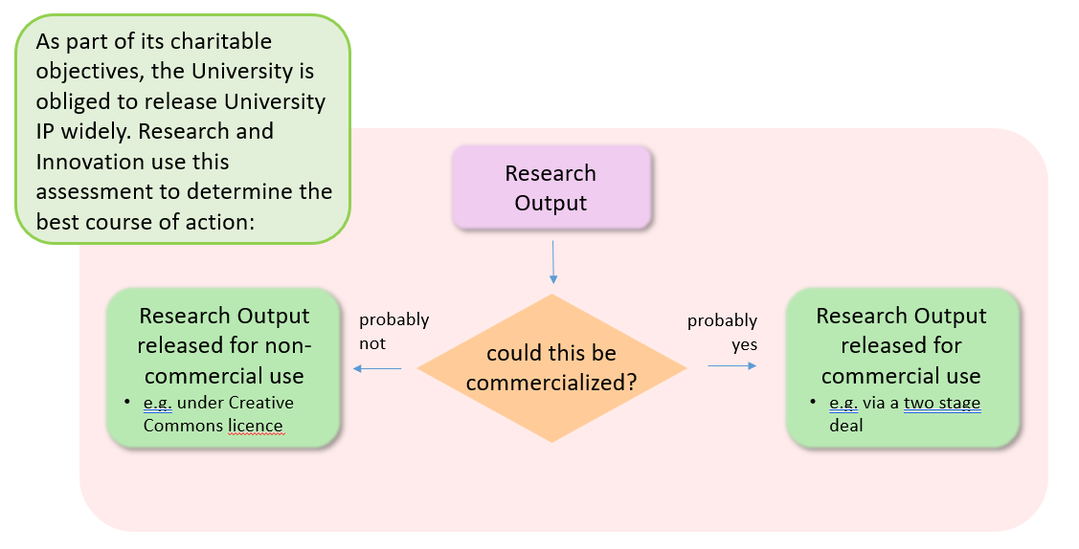
Diagram 4: triage Research and Innovation use to decide how University IP should be released
5.1 Release of University IP for Non-Commercial Use
5.1.1 The University recognises that Commercialisation of University IP via a Commercial Partnering Arrangement may not always be appropriate and sometimes it is in the best interests of knowledge transfer to make the University IP available under a permissive creative commons licence or a permissive open source licence or occasionally to dedicate the University IP to the public domain. Diagram 5 shows which off-the-shelf licence should be used to release University IP for non-commercial use.
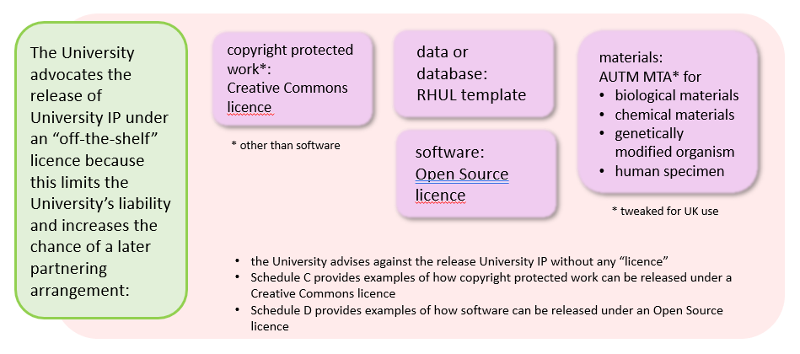
Diagram 5: an overview of which off-the-shelf licence should be used to release University IP for non-commercial use
5.1.2 If the Originator believes that any of the options set out under section 5.1 is appropriate, he or she must discuss and agree this with his or her Authoriser, Academic Supervisor, or Host, as the case may be, as appropriate.
5.1.3 Where the University IP was created with the support of a Third Party, then the Authoriser, Academic Supervisor, or Host, as appropriate, must discuss and agree the position with the University and the Third Party before the Originator makes the University IP available under a permissive creative commons licence or a permissive open source licence or dedicates the University IP to the public domain.
5.1.4 Schedule C (Release of a copyright protected work (other than software) which is University IP under a Creative Commons licence) sets out examples of where it was decided that it was appropriate for University IP to be release for non-commercial use under a permissive creative commons licence.
5.2 Release of University IP for Commercial Use - Commercial Partnering Arrangements
5.2.1 Principles
5.2.1.1 The University itself does not Commercialise University IP and instead enters into a Commercial Partnering Arrangement with a Third Party to allow the Third Party to Commercialise University IP. Therefore there are two distinct phases:
- entering into a Commercial Partnering Arrangement (which sets out how the Third Party will Commercialise the IP), and
- reviewing the Commercial Partnering Arrangement to monitor whether the Third Party is Commercialising the IP or making sufficient progress towards Commercialising the IP.
5.2.1.2 There are four Commercial Partnering Arrangements which the University takes to allow University IP to be Commercialised via a Third Party:
- A Commercial Partnering Arrangement with an existing Third Party via the grant of a Licence by the University to the Third Party (see section 6.3) under a Pull Scenario where the Third Party was involved in the creation of the University IP (as is often the case where a Third Party provides input into a grant funded project as a project partner where a Third Party collaborates with the University under an Innovate UK grant funded project), or
- A Commercial Partnering Arrangement with an existing Third Party via the grant of a Licence by the University to the Third Party (see section 6.4) under a Push Scenario where the Third Party was not involved in the creation of the University IP (as is often the case for other grant funded research), or
- A Commercial Partnering Arrangement with the Originator(s) to allow the Originator(s) to form a Self-Commercialisation Company to Commercialise University IP (see section 6.5), or
- A Commercial Partnering Arrangement with the Originator(s), at least one further director, and at least one further investor to form a Spin-Out Company (see section 6.6).
5.2.1.3 The order in which the Commercial Partnering Arrangements are set out in section 6.1.2 reflects the University’s preference.
5.2.1.4 As set out in section 4.7, each Originator must disclose to the University any University IP which is potentially Commercialisable and must in the IP Disclosure Form set out which Commercial Partnering Arrangement as set out in section 6.1.2 he or she believes is most appropriate for the particular University IP.
5.2.1.5 Although the Originator(s) and the University’s interests will often be the same, the University recommends that all Originator(s) seek independent advice at his or her own cost. Putting in place and monitoring a Commercial Partnering Arrangement is time consuming and so each Originator’s Authoriser, Academic Supervisor, or Host, as the case may be, must be aware of and agree with the Commercial Partnering Arrangement proposed by the Originator(s) in the IP Disclosure Form.
5.2.1.6 Knowledge Exchange will review whether the Commercial Partnering Arrangement that the Originator(s) propose is appropriate and may recommend a different arrangement.
5.2.1.7 Irrespective of which Commercial Partnering Arrangement the University agrees to, the University is obliged to periodically monitor the Commercial Partnering Arrangement to ensure that the (preparations leading to) Commercialisation is or are proceeding as planned and in line with the Funder(s)’ requirements (if applicable), the University’s charitable obligations, and the University’s social responsibility (see section 6.9).
5.2.1.8 The University cannot accept any liability to the Originator(s) if the return achieved through a Commercial Partnering Arrangement is not the best financial return which could have been achieved. In any event, the best financial return may not be compatible with section 6.10.

6. IP Management
Where it becomes clear that any University IP is Potentially Commercialisable, the University has an obligation to manage the particular University IP. The University has chosen to do so via the Commercial Partnering Panel. Section 6.1 explains who in Research and Innovation can advise whether a particular piece of University IP is Potentially Commercialisable.
6.1 Departments that assist with the management of University IP
Diagram 6 shows that all teams in Research and Innovation support an understanding of what research outputs / IP is created at the University. Diagram 6 also shows that both Knowledge Exchange and Research Contracts can advise whether a particular piece of University IP is Commercialisable. It is recommended that Employees discuss:
- with Research Contracts what research outputs they or their collaborators expect to create before a project begins. In that context the research contracts manager will advise the Employee if any prospective University IP appears to be Commercialisable.

- with Knowledge Exchange what research output they have created after a project has started. In that context the knowledge exchange manager will advise the Employee if any newly created University IP appears to be Commercialisable.
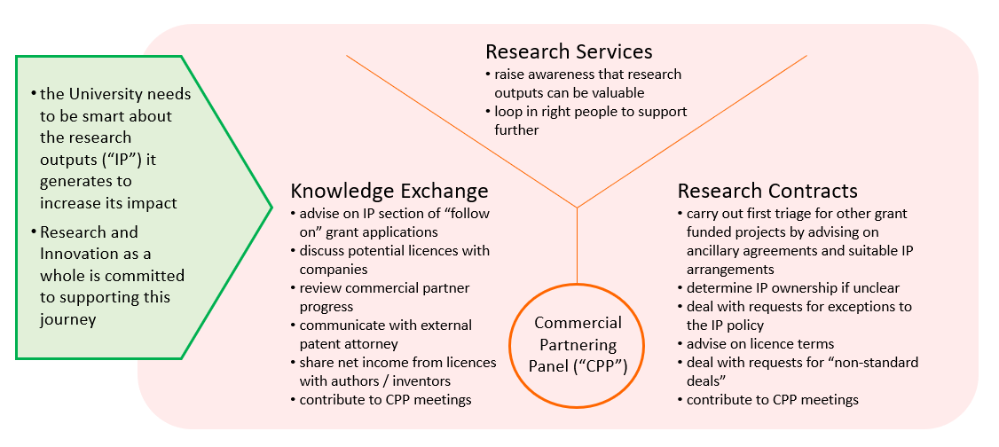
Diagram 6: all teams in Research and Innovation support an understanding research outputs / IP
6.2 The Commercial Partnering Panel’s role
6.2.1 The Commercial Partnering Panel was established in January 2020 to assist with the University’s obligation to manage University IP.
6.2.2 The Commercial Partnering Panel meetings are monthly (with the exception of August and December) to review:
- existing IP Protection,
- existing Partnering Arrangements,
- requests for new IP Protection,
- requests for non-standard deals,
- requests for exceptions to the IP Policy,
- requests for clarification on IP ownership,
- requests for internal funding if the funding is required in order to make existing University IP more Commercialisable,
- risk mitigations which involve the Commercial Partnering Panel,
- any proposed changes to the IP Policy or IP Framework,
- any other matters that relate to or impact on the University’s ability to effectively manage IP,
- any other matters that relate to or impact on the University’s ability to effectively manage potential conflicts of interest from an IP perspective, and
- any other matters to relate to or impact on the University’s ability to Commercialise University IP.
6.2.3 The Commercial Partnering Panel typically reviews ten matters each matter and includes for each relevant matter the most-directly affected Employee, the relevant Director of Research and Knowledge Exchange, the relevant Executive Dean, and the relevant Head of Department, the Director of Research and Innovation, and staff from Knowledge Exchange and Research Contracts.
6.2.4 Decisions made by the Commercial Partnering Panel are shared with the Research and Knowledge Exchange Committee via a quarterly report.
6.2.5 Investment decisions recommended by the Commercial Partnering Panel need approval from the Budget and Capital Planning Committee and the Finance Committee.
6.3 Commercial Partnering Arrangement with an existing Third Party under a Pull Scenario
6.3.1 Under a Pull Scenario (sometimes referred to as an arrangement with a lined up Licensee), there is already an agreement in place with at least one Third Party that sets out that the University is prepared to grant a Licence to the Third Party (via a time-limited option) and who is responsible for Protecting the University IP. Having such a shared understanding facilitates the Commercialisation of University IP developed under a Pull Scenario.
6.3.2 If the Originator(s) become aware that any University IP which is developed under a Pull Scenario is Commercialisable, he or she should complete an IP Disclosure Form and include in the form:
- a description of the University IP,
- the fact that a Pull Scenario is in place,
- the name of the Third Party (i.e. the potential Licensee) in the Pull Scenario,
- why the Originator(s) believe that the University IP would be of interest to the potential Licensee, and
- whether or not the Originator(s) believe that the University IP should be Protected.
6.3.3 Upon receipt of an IP Disclosure Form which includes a request to enter into a Commercial Partnering Arrangement with an existing Third Party under a Pull Scenario, Knowledge Exchange will review the information contained within the IP Disclosure Form and then follow up with the Third Party (i.e. the potential Licensee) in accordance with the existing agreement set out in section 6.3.1. Knowledge Exchange will include the Originator(s) in any correspondence with the Third Party.
6.4 Commercial Partnering Arrangement with an existing Third Party under a Push Scenario
6.4.1 If the Originator(s) of some University IP decide that the best way to Commercialise the IP is to enter into a Commercial Partnering Arrangement with an existing Third Party (i.e. via the grant of a Licence to a Third Party), the Originator(s) shall complete an IP Disclosure Form and include in the form:
- a description of the University IP,
- a request that the University enters into a Commercial Partnering Arrangement with an existing Third Party under a Push Scenario,
- the name of at least one potential Licensee,
- why the Originator(s) believe that the University IP would be of interest to the potential Licensee, and
- whether or not the Originator(s) believe that the University IP should be Protected.
6.4.2 For the avoidance of doubt the University will generally only agree to enter into a Commercial Partnering Arrangement with an existing Third Party under a Push Scenario if the Third Party can agree to:
- reimburse the University any expenses incurred by the University for Protecting the relevant University IP,
- pay to the University the Buy-Out Fee or a Royalty (which normally is a minimum annual Royalty).
6.4.3 Upon receipt of an IP Disclosure Form which includes a request to enter into a Commercial Partnering Arrangement with an existing Third Party under a Push Scenario, Knowledge Exchange will review the information contained within the IP Disclosure Form.
6.4.4 If Knowledge Exchange requires further information to decide whether the University IP disclosed in the IP Disclosure Form can be Commercialised via the requested Commercial Partnering Arrangement, it will ask the Originator(s) to provide the missing information and take such steps it believes necessary to find out any information it requires to make a decision.
6.4.5 Once Knowledge Exchange has all the information it will present the case to the Commercial Partnering Panel in the presence of the Originator(s) so the Commercial Partnering Panel can decide whether the University is prepared to invest in the negotiations with the potential Licensee(s) and, if appropriate, the Protection of the University IP.
6.4.6 If the Commercial Partnering Panel decides to Commercialise all or any of the University IP disclosed in the IP Disclosure Form via the requested Commercial Partnering Arrangement, Knowledge Exchange will contact the potential Licensee(s) to discuss the grant of a Licence by the University to the potential Licensee(s). Knowledge Exchange will include the Originator(s) in any correspondence with the potential Licensee(s).
6.4.7 Where a potential Licensee is willing to enter into a Licence, Knowledge Exchange will ask Research Contracts to prepare a draft Licence to share with the potential Licensee.
6.4.8 As a rule Knowledge Exchange will spend up to three months with the efforts set out in sections 6.4.6 and 6.4.7. If Knowledge Exchange does not receive any feedback from a potential Licensee this is an indication that the University IP is not of sufficient commercial interest.
6.4.9 Where Knowledge Exchange, the Commercial Partnering Panel, or feedback from a potential Licensee indicates that there is insufficient interest in the University IP, Knowledge Exchange may recommend that Knowledge Exchange cease their efforts and that the Originator(s) apply for Follow-On Funding to further develop the University IP.
6.4.10 Where Knowledge Exchange, the Commercial Partnering Panel, or feedback from a potential Licensee indicates that the University IP is not of sufficient commercial interest, then the provisions set out in section 6.8 apply.
6.5 Commercial Partnering Arrangement with the Originator(s) to allow the Originator(s) to form a Self-Commercialisation Company
6.5.1 If all Originator(s) of some University IP decide that the best way to Commercialise the IP is via Self-Commercialisation, the Originator(s) shall complete a Request to Self-Commercialise Form and include in the form:
- a description of the University IP,
- a request that the University enters into a Commercial Partnering Arrangement with the Originator(s),
- why the Originator(s) believe that entering a Commercial Partnering Arrangement with an existing Third Party is not appropriate and how the Originator(s) propose to Commercialise the IP (in the form of a business plan),
- the expected duration of the Set Up Phase,
- whether the Originator(s) request assignment of or a licence to the University IP,
- whether the Originator(s) expect to be involved with the new company only during the Set Up Phase and then return to being a full time Employee, or, whether Originator(s) expect to be involved with the new company during the Set Up Phase and then cease to be Employees thereafter, and
- whether or not the Originator(s) believe that the University IP should be Protected.
6.5.2 For the avoidance of doubt:
- the University may agree to allow an Originator who is already an Employee to remain an Employee during the Set Up Phase (i.e. this would be an in kind contribution of the University to the newly formed company),
- the University will only agree to enter a Commercial Partnering Arrangement with the Originator(s) if the Originator(s) can agree to a) reimburse the University any expenses incurred by the University for Protecting the relevant University IP, and b) pay to the University the Buy-Out Fee or a Royalty (which is normally a minimum annual Royalty).
6.5.3 Upon receipt of a Request to Self-Commercialise Form, Knowledge Exchange will review the information contained within the Request to Self-Commercialise Form.
6.5.4 If Knowledge Exchange requires further information to decide whether the University IP disclosed in the Request to Self-Commercialise Form can be Commercialised via the requested Commercial Partnering Arrangement, it will ask the Originator(s) to provide the missing information and take such steps it believes necessary to find out any information it requires to make a decision.
6.5.5 Once Knowledge Exchange has all the information it will present the case to the Commercial Partnering Panel in the presence of the Originator(s) so the Commercial Partnering Panel can decide whether the University is prepared to a) allow the Originator(s) to set up a Self-Commercialisation Company, b) grant a licence to (or assign) the University IP to the Self-Commercialisation Company, and c) if appropriate, invest in the Protection of the University IP.
6.5.6 If the Commercial Partnering Panel decides to Commercialise all or any of the University IP disclosed in the Request to Self-Commercialise Form via the requested Commercial Partnering Arrangement, Knowledge Exchange will work with the Originator(s) to define the parameters of the Self-Commercialisation. For the avoidance of doubt, Research Contracts will prepare a company formation agreement which needs to be signed by each Originator and the University to capture the shared understanding.
6.5.7 The Originator(s) will not set up the Self-Commercialisation Company until the company formation agreement mentioned in section 6.5.6 has been signed.
6.5.8 As a rule Knowledge Exchange will spend up to three months with the efforts set out in sections 6.5.6 and 6.5.7.
6.5.9 Where Knowledge Exchange, the Commercial Partnering Panel, or feedback from the Originator(s) indicates that Self-Commercialisation is not viable or that terms cannot be agreed between the University and the Originator(s), Knowledge Exchange may revise the Request to Self-Commercialise Form to state that the University IP will be Commercialised by entering a Commercial Partnering Arrangement with an existing Third Party under a Push Scenario or via the formation of a Spin-Out Company and then follow the process as set out in section 6.4 or section 6.6.
6.6 Commercial Partnering Arrangement with the Originator(s) to form a Spin-Out Company
6.6.1 If all Originator(s) of some University IP decide that the best way to Commercialise the IP is via the formation of a Spin-Out Company, the Originator(s) shall complete an IP Disclosure Form and indicate in the form:
- a description of the University IP,
- a request that the University together with the Originator(s) form a Spin-Out Company,
- why the Originator(s) believes that entering into a Commercial Partnering Arrangement via an existing Third Party under a Push Scenario is not appropriate, why the Originator(s) cannot Self-Commercialise, and how the Originator(s) propose to Commercialise the IP (in the form of a business plan),
- an indication whether the Originator(s) intend to be director(s) of the Spin-Out Company during the Set Up Phase,
- the name of at least one individual who has skills which complement the Originator(s) skill (usually by having business experience) who is prepared to be a (further) director of the Spin-Out Company,
- the name of at least one Third Party who is prepared to co-invest in the Spin-Out Company,
- the duration of the Set Up Phase,
- an indication whether the Originator(s) request assignment of or a licence to the University IP to the Spin-Out Company,
- an indication whether the Originator(s) expect to be involved with the new company only during the Set Up Phase and then return to being a full time Employee, or, whether the Originator(s) expect to be involved with the new company during the Set Up Phase and then cease to be Employees thereafter, and
- whether or not the Originator(s) believe that the University IP should be Protected.
6.6.2 Upon receipt of an IP Disclosure Form which includes a request to form a Spin-Out Company, Knowledge Exchange will review the information contained within the IP Disclosure Form.
6.6.3 If Knowledge Exchange requires further information to decide whether the University IP disclosed in the IP Disclosure Form can be Commercialised via a Spin-Out Company, it will ask the Originator(s) to provide the missing information and take such steps it believes necessary to find out any information it requires to make a decision.
6.6.4 Once Knowledge Exchange has all the information it will present the case to the Commercial Partnering Panel in the presence of the Originator(s) so the Commercial Partnering Panel can decide whether the University is prepared to invest in the formation of a Spin-Out Company (and, if appropriate, the Protection) of the University IP.
6.6.5 If the Commercial Partnering Panel decides to Commercialise all or any of the University IP disclosed in the IP Disclosure Form via the formation of a Spin-Out Company, Knowledge Exchange will contact the potential further director(s) and co-investor(s).
6.6.6 Knowledge Exchange will keep the Originator(s) informed of the progress in identifying potential further directors and co-investors and any feedback provided by potential further directors and co-investors.
6.6.7 Where the Originator(s), potential further directors, and co-investors are willing to enter into a term sheet for new company formation (which will eventually lead to a shareholders agreement), Knowledge Exchange will ask Research Contracts to prepare a draft term sheet for new company formation to share this with the Originator(s), potential further directors, and co-investors.
6.6.8 As a rule Knowledge Exchange will spend up to three months identifying potential further directors and co-investors and up to three months trying to interest a potential further director or co-investor in becoming involved with the University IP. If Knowledge Exchange does not receive any feedback from a potential further director or co-investor that this is an indication that the University IP is not of sufficient commercial interest.
6.6.9 Where Knowledge Exchange, the Commercial Partnering Panel, or feedback from the Originator(s), or potential further directors or co-investors indicates that Commercialisation via a Spin-Out Company is not viable or that terms cannot be agreed between the University, the Originator(s), and the potential further directors or co-investors, Knowledge Exchange may revise the IP Disclosure Form to state that the University IP will be Commercialised by entering into a Commercial Partnering Arrangement with a Third Party under a Push Scenario and then follow the process as set out in section 6.4.
6.7 Originator Assistance and Obligations
6.7.1 Irrespective of which Commercial Partnering Arrangement the University agrees to with respect to the relevant University IP, each Originator of the relevant University IP shall provide reasonable assistance in the Commercialisation of the University IP by providing additional information on request, attending meetings with a potential Licensee, a potential further director, or a potential investor and advising on further development(s) which relate to the University IP.
6.8 Possible Assignment University IP to the Funder, a Technology Transfer Organisation, or the Originator(s)
6.8.1 If the Commercial Partnering Panel decides not to invest in the setting up of a Commercial Partnering Arrangement or if the efforts of Knowledge Exchange show that there is insufficient interest in the University IP, then Knowledge Exchange should offer the University IP to the Funder(s) irrespective of whether or not the Funder terms require the University to do so.
6.8.2 In parallel to section 6.8.1, Knowledge Exchange should consider whether there is a Technology Transfer Organisation which may be interested in the University IP and contact any relevant Technology Transfer Organisation.
6.8.3 If neither the Funder(s) nor a Technology Transfer Organisation wish to take assignment of the University IP then each of the Originator(s) may request that the University assigns such University IP to them.
6.8.4 The University may, following such request, after consideration and at its sole discretion, assign all its right, title and interest in such University IP to the Originator(s) provided that the Funder terms and/or the terms of any agreement that supported or related to the creation of such IP allows the University to do so.
6.8.5 For the avoidance of doubt, the University will generally only assign the University IP to the Originator(s) if the Originator(s) can agree to:
- reimburse the University any expenses incurred by the University for Protecting the relevant University IP,
- pay to the University the Buy-Out Fee or a Royalty (which normally is a minimum annual Royalty).
6.9 Use of University’s name
6.9.1 Each Originator agrees that if he or she is allowed to Self-Commercialise any University IP as set out in section 6.5 or if the University assigns any University IP to him or her under section 6.8, he or she will not, and will procure that anyone to whom they license or assign such IP does not, use the University’s name in any way, without the University’s written consent.
6.10 Social Responsibility
6.10.1 The University must ensure that any Commercial Partnering Arrangement:
- is in line with the Funder(s)’ requirements (if applicable),
- is in line with the University’s charitable obligations,
- does not violate European State Aid regulations (if applicable),
- will not adversely affect its reputation, and
- is in line with Schedule J (The University’s Position on Non-Commercial Partnering Arrangements) (if applicable).
6.11 Timetable for setting up a Commercial Partnering Arrangement
6.11.1 The timescale for setting up a Commercial Partnering Arrangement for University IP will depend upon market conditions and the state of development of the University IP. The discussions between Knowledge Exchange, the Originator(s), and the School(s) should set a reasonable initial timetable with regular review points. However, everyone must recognise that circumstances may change as the process develops.
6.11.2 If the Originator(s) believe that Knowledge Exchange is not acting in a timely manner, then the Originator(s) may bring this to the attention of the Director of Research and Innovation in the first instance.
6.12 Monitoring of Commercial Partnering Arrangements
6.12.1 As set out in section 6.1.1, the signature of any agreement which sets out a Commercial Partnering Arrangement is only the start of the Commercialisation process and the University is obliged to periodically review each Commercial Partnering Arrangement it has entered into.
6.12.2 In order to review an existing Commercial Partnering Arrangement, Knowledge Exchange will ask the Commercial Partner to provide information and evidence to demonstrate that the Commercial Partner is making progress with (the preparations leading to) the Commercialisation of the University IP.
6.12.3 If Knowledge Exchange requires further information to decide whether the University IP is being Commercialised to the University’s satisfaction, it will ask the Commercial Partner(s) to provide the missing information and take such steps it believes necessary to find out any information it requires to make a decision. Failure of a Commercial Partner to provide such information and evidence will be interpreted to mean that the Commercial Partner has not made sufficient progress.
6.12.4 Once Knowledge Exchange has all the information it will present the information to the Commercial Partnering Panel in the presence of the Originator(s) so the Commercial Partnering Panel can decide whether the University is satisfied with the Commercialisation and therefore prepared to continue with the existing Commercial Partnering Arrangement or whether the University has any concerns about the Commercialisation and therefore would like to amend or terminate the existing Commercial Partnering Arrangement.
6.12.5 If the Commercial Partnering Panel decides to terminate an existing Commercial Partnering Arrangement, it may explore alternative Commercial Partnering Arrangements or may follow the processes as set out in section 6.8.
6.13 Protection of University IP - potentially patentable invention
6.13.1 In many cases University IP will automatically be protected by an unregistered form of IP such as copyright or a database right. The advantage of such protection is that it is free, and the disadvantage is that the University would need to prove that a Third Party has copied (part of) the University IP in order to establish IP infringement. For the avoidance of doubt, a technical design (such as an engineering drawing) is protected by copyright (rather than by design right).
6.13.2 In some case it may be possible to protect University IP by a registered form of IP such as a patent application. The advantage of such protection is that there is no need to prove that a Third Party has copied (part of) the University IP in order to establish IP infringement, and the disadvantage is that such protection is expensive both in terms of costs and further research support.
6.13.3 Therefore, with respect to potentially patentable inventions, the University will only Protect University IP if it has entered into a Commercial Partnering Arrangement or has reason to believe that it will enter into a Commercial Partnering Arrangement which will cover the cost of Protecting the relevant University IP. For the avoidance of doubt, the University does not have any obligation to Protect the University IP in any particular country or territory.
6.13.4 The University will not Protect any IP which is not University IP. As set out at section 4.2.4, any Originator may offer to assign the IP which he or she owns to the University and needs to assign his or her IP to the University should he or she wish for the University to Protect such IP.
6.13.5 If the Commercial Partnering Panel agrees to invest in the Protection of any particular University IP, then Knowledge Exchange shall proceed in a timely manner to take appropriate steps to Protect the relevant University IP.
6.13.6 As IP Protection is expensive, the University is obliged to periodically monitor any IP Protection it has applied for to ensure that the cost of the IP Protection is in line with Funder(s)’ requirements (if applicable), the University’s charitable obligations, and the University’s social responsibility (see section 6.9). For the avoidance of doubt, the University does not have any obligation to prosecute any patent application(s) nor to maintain any granted patents.
6.13.7 In particular, the University will generally only agree to pay to file a first, national patent application and a corresponding international patent application but will then cease to pay the national phase entry costs (or the costs of patent prosecution, patent maintenance, and patent defence) unless a Commercial Partner has agreed to pay for these costs and is paying such costs.
6.13.8 If the University decides not to maintain registered IP protection, the University will follow the processes set out in section 6.8.
6.13.9 As set out in section 6.6, it is not permissible for an Employee, a Postgraduate Student, an Academic Visitor, an Undergraduate Student, or a University of London Student to Protect any University IP (whether in the name of the University or otherwise) or allow a third party to Protect any University IP (whether in the name of the University or otherwise). If an Employee, a Postgraduate Student, an Academic Visitor, an Undergraduate Student, or a University of London Student wishes to Protect (or allow a third party to Protect) any University IP, he or she must seek formal approval by following the process set out in section 6.16 (Exception Procedure).
6.14 Protection of University IP - trade mark
6.14.1 In many cases University IP will automatically be protected by an unregistered form of IP such as unregistered trade mark protection and passing off. The advantage of such protection is that it is free, and the disadvantage is that the University would need to prove that a Third Party has copied (part of) the University IP in order to establish IP infringement.
6.14.2 In some case it may be possible to protect University IP by a registered form of IP such as a trade mark application. The advantage of such protection is that there is no need to prove that a Third Party has copied (part of) the University IP in order to establish IP infringement, and the disadvantage is that such protection is expensive in terms of costs.
6.14.3 Therefore, with respect to trade marks, the University will only Protect University IP if the University:
- believes that Protection is important from a commercial perspective, or
- is obliged to obtain such protection under a funding agreement.
6.14.4 The University will not Protect any IP which is not University IP. As set out at section 4.2.4, any Originator may offer to assign the IP which he or she owns to the University and needs to assign his or her IP to the University should he or she wish for the University to Protect such IP.
6.14.5 If the Commercial Partnering Panel agrees to invest in the Protection of any particular University IP, then Knowledge Exchange shall proceed in a timely manner to take appropriate steps to Protect the relevant University IP.
6.14.6 As IP Protection is expensive, the University is obliged to periodically monitor any IP Protection it has applied for to ensure that the cost of the IP Protection is in line with Funder(s)’ requirements (if applicable), the University’s charitable obligations, and the University’s social responsibility (see section 6.9). For the avoidance of doubt, the University does not have any obligation to prosecute any trade mark application nor to maintain any granted trade mark.
6.14.7 In particular, the University will generally only agree to pay for trade mark protection in the United Kingdom.
6.14.8 As set out in section 6.6, it is not permissible for an Employee, a Postgraduate Student, an Academic Visitor, an Undergraduate Student, or a University of London Student to Protect any University IP (whether in the name of the University or otherwise) or allow a third party to Protect any University IP (whether in the name of the University or otherwise). If an Employee, a Postgraduate Student, an Academic Visitor, an Undergraduate Student, or a University of London Student wishes to Protect (or allow a third party to Protect) any University IP, he or she must seek formal approval by following the process set out in section 6.16 (Exception Procedure).
6.15 Protection of University IP - other forms of Protection
6.15.1 In many cases University IP will automatically be protected by an unregistered form of IP such as unregistered design right. The advantage of such protection is that it is free, and the disadvantage is that the University would need to prove that a Third Party has copied (part of) the University IP in order to establish IP infringement.
6.15.2 In some case it may be possible to protect University IP by a registered form of IP such as applying for a registered design right or plant breeders’ rights. The advantage of such protection is that there is no need to prove that a Third Party has copied (part of) the University IP in order to establish IP infringement, and the disadvantage is that such protection is expensive in terms of costs.
6.16 Share of Net Income
6.16.1 As set out in section 5.2 (Release of University IP for commercial purpose - Commercial Partnering Arrangements), irrespective of which Commercial Partnering Arrangement the University has entered into with respect of any particular University IP, the Commercial Partnering Arrangement will usually set out that the Third Party will pay a Royalty to the University.
6.16.2 Subject to section 6.16.3, the University agrees to share the Net Income received under a Commercial Partnering Arrangement with the Originator(s) as set out in Schedule I (Detailed provisions about the sharing of Net Income). For the avoidance of doubt, the University will not share the Net Income it receives from Commercialising Teaching Material and/or University Material.
6.16.3 The University will continue to share the Net Income in accordance with the University’s 2011 Exploitation of Inventions and Patents Code of Practice for any income received for a technology which was notified to Knowledge Exchange up until 31st December 2020 provided that the Commercial Partnering Arrangement for that technology was signed up until 31st December 2020.
6.16.4 Net Income means the Royalty which the University receives under a Commercial Partnering Arrangement with respect to certain University IP less the following incurred direct costs namely:
- Value Added Tax, when applicable,
- any direct costs associated with the Protection of the University IP;
- any other expenses directly related to the setting up or review of the Commercial Partnering Arrangement;
- any payment due under a revenue sharing agreement to a Third Party in relation to the University IP; and
- any other expenses directly related to the administration or distribution of Net Income including but not limited to the employer’s national insurance contribution incurred.
6.16.6 For the avoidance of doubt, Schedule I (Detailed provisions about the sharing of Net Income) sets out that:
- the University will share the Net Income with the Originator(s) unless the Originator(s) are already benefitting from the Commercialisation,
- the University will share the Net Income with the Originator(s) unless there are more than three Originators and it would be too onerous on the University to share the Net Income with the Originators,
- the University will share the Net Income with an Originator unless an Originator has agreed to waive his/her income under a specific Licence,
- the University will pass any funds due to any Originator to the Originator even if he or she has ceased to be an Employee, a Postgraduate Student or an Academic Visitor for any reason unless an Originator transfers to another organisation and the University agrees to assign the relevant University IP to the organisation and passes the obligation to share Net Income to the other organisation, and
- the University will pass any funds due to any Originator to his or her estate in the event that the Originator is deceased.
6.16.6 The University may decide not to implement the processes in Schedule I (Detailed provisions about the sharing of Net Income) if:
- such Net Income is so substantial that it would be inappropriate as a charitable organisation for them not to be reinvested in the University’s charitable objects; or
- the University has provided additional service and/or investment; or
- the Commercialisation results from the Self-Commercialisation of any University IP as set out in section 6.4 or the Commercialisation of University IP which the University has assigned to the Originator(s) under section 6.7.
6.17 Exception Procedure
6.17.1 Should any Employee, Postgraduate Student, or Academic Visitor feel that this Framework (including any Schedule) should not apply to the IP that he or she has created and would like to propose a different course of action, he or she should raise this matter with the Commercial Partnering Panel. For the avoidance of doubt, this could be a request that IP created by an Undergraduate Student (who is not an Employee) be assigned to the University.
6.17.2 Should any staff from Research and Innovation believe that this Framework (including any Schedule) should not apply to any particular IP and would like to propose a different course of action, he or she should raise this matter with the Commercial Partnering Panel. For the avoidance of doubt, this could be a request that Net Income not be shared with the Originators where there are more than three Originators.
6.17.3 The Commercial Partnering Panel will consider the request of the Employee, Postgraduate Student, Academic Visitor, or staff from Research and Innovation and has the authority to:
- agree to the request,
- suggest another a variation to the request, or
- reject the request.
6.17.4 Any variation which the Commercial Partnering Panel agrees to needs to be time-limited and does not create a precedent.

7. DISPUTE PROCEDURE
7.1 Initial Referral
If there is any dispute in relation to a matter arising out of this Framework or in relation to the interpretation of this Framework (other than a dispute relating to the timetable set out in section 4.9 or as set out in section 3.3.1), then it will be referred in the first instance to the Director of Research and Innovation.
7.2 Subsequent Referral
If such individuals are unable to reach a unanimous decision, or if the dispute relates to the timetable set out in section 4.9, then the matter will be referred to the Vice Principal for Academic Strategy and Research.
7.3 Appeal
If a party to the dispute disagrees with the decision made pursuant to section 7.2 above, that party shall have a right of appeal to the Principal (or such individual as the Principal shall nominate). The Principal’s (or nominee’s) decision on the matter shall be final.
7.4 Undergraduate Student and University of London Student Dispute
Where a party to such a dispute is an Undergraduate Student or a University of London Student, the Undergraduate Student or the University of London Student may be accompanied during any appeal by a fellow student, a student representative from the University or its Students’ Union or a member of staff of the University of his or her own choice, all of whom may act as an observer.

SCHEDULE A
Glossary

Academic Supervisor | means a Postgraduate Student’s academic advisor or supervisor.
Academic Visitor | means an individual who visits the University for more than five days in a calendar year or has an honorary appointment with the University, but who is not an Employee, a Postgraduate Student, an Undergraduate Student, or a University of London Student.
Academic Visitor IP | means IP which belongs to an Academic Visitor; this may include IP created by the Academic Visitor outside of his or her visit to the University and may include Artistic Material and Scholarly Material.
Artistic Material | means any material of an artistic nature created by an Employee in the course of his or her employment, created by a Postgraduate Student in the course of his or her studies, or created by an Academic Visitor in the course of his or her visit, such as:  - an artistic work (including an artistic photograph, collage, drawing, engraving, etching, lithograph, and painting);  - a dance or drama choreography (including mime);  - a dramatic work (including a novel, play, poem, and popular fiction and non-fiction);  - a graphic work (including concept art and logo design);  - a film and/or sound recording (including video material);  - a musical work (including any lyric and music score); and  - a work of artistic craftsmanship or fine art;  but excluding any such material or part of the material which forms part of a Teaching Material or a University Material.
Authoriser | means the line manager of an Employee;
Buy-Out Fee | means a one-off payment from a Third Party who wishes to Commercialise University IP to the University to cover the difference between the payment made by the Third Party to the University and the amount the University would have charged the Third Party if the Third Party had commissioned the University to develop the University IP for it;
Commercialisation | means the sale of a product, provision of a service or similar which involves or is based on certain University IP whether in return for cash or payment in kind, but does not include the delivery of courses by the University whether on its own or in collaboration with a Third Party. The terms “Commercialise”, “Commercialisable” and “Commercialised” shall be construed accordingly.
Commercial Partnering Panel | means the panel which was set up by the University’s council to allow the University to manage IP as set out in more detail in section 6.2 (The Commercial Partnering Panel’s role).
Commercial Partner | means to enter into a legal agreement with an individual or a Third Party to allow that individual or Third Party to Commercialise certain University IP and the term “Commercial Partnering” shall be construed accordingly; for the avoidance of doubt, the term “Partner” in the context of this Framework is different to the legal concept of a partnership.
Community Interest Company or CIC | means a type of company known as such and introduced under the Companies (Audit, Investigations and Community Enterprise) Act 2004, designed for social enterprises that want to use its profits and assets for the public good.
Contracts Legal Review Process | means the University internal document which sets out who is an authorised signatory of certain types of agreements and whether Legal Services need to review an agreement.
Contributor | means any Employee, Student, or Academic Visitor who is not a relevant Originator but  - is employed specifically to develop particular University IP further, e.g. to reduce such University IP to practice or to work on a proof of principle project in respect of such IP or to generate supporting data in respect of such IP, or  - works on a project as part of their studies or due to their relationship with a relevant Originator, e.g. collaborative working as part of a School’s activities.
Dispute Procedure | means the procedure set out in section 7.
Employee | means an employee of the University.
Employee IP | means IP which belongs to an Employee; this may include IP created by the Employee outside of the course of his or her employment and may include an Artistic Material and/or a Scholarly Material.
Framework | means this Framework for the implementation of the IP policy.
Funder | means any Third Party who has funded or who will fund a research project (including any student led research project) at the University.
Host | means the Academic who is hosting the Academic Visitor.
Incidental Use of University Resources | generally, IP will not be considered to have been created with more than incidental use of University Resources if:  - only a small amount of University funds has been used;  - only a small amount of time has been spent using University Resources or only insignificant University Resources have been used, such as use of office space, library and other general use of information sources, personal computers and personal office equipment or, in the case of an Undergraduate Student or a University of London Student, who is an Employee, the use has been in the course of his or her University course work; and  - the IP has been created during the personal, unpaid time of the Originator.  The issue of whether significant use has been made of University Resources will be reviewed by the Originator’s Authoriser, Academic Supervisor, or Host, as the case may be, who will make a recommendation to Research and Innovation. If an Originator is in any doubt as to what constitutes “incidental use” or a “small amount of” University funds or University Resources then the Originator should discuss this with his or her Authoriser, Academic Supervisor, or Host.
Innovation and Enterprise Working Group | means the working group set up by the Research and Knowledge Exchange Committee which decides on the principles of how the University will collaborate with Third Parties and Commercialise University IP.
IP Policy | means the University’s 2021 Intellectual Property and Commercial Partnering Policy.
Intellectual Property or IP | means any algorithm, biological material, chemical material, data, database (including the database rights) design right, device, domain name, genetically modified organism, human specimen, image, method description (including rights in any trade secret), patentable technology (including but not limited to a patent application, granted patent, and any extension or renewal thereof), patient questionnaire, plant variety (including the plant breeders’ rights), software, teaching material (such as a lecture note, course handout, audio or visual recording of a lecture) and other copyright protected work, prototype (including a prototype device), technical data, technical design (such as an engineering drawing), topography (such as a circuit diagram, integrated circuit chip and including any topography rights), trade mark (including any rights to prevent passing off), and/or, and in each and every case all rights or forms of protection having equivalent or similar effect anywhere in the world.
Intellectual Property Disclosure Form | means the form to be used when disclosing IP to Research and Innovation.
Licence | is an example of a Commercial Partnering Arrangement whereby the University allows a Third Party to Commercialise some University IP (whether on its own or with other IP) in return for a Royalty. The term Licence covers an assignment, an evaluation licence, a commercial licence, a patent ownership and management agreement or a revenue share agreement with a Third Party where the purpose of the assignment, evaluation licence, commercial licence, patent ownership and management agreement or revenue share agreement is equivalent to the purpose of a Licence.
Net Income | means the net income which the University receives under a Commercial Partnering Arrangement with respect to certain University IP and is defined as the total income less the following incurred direct costs namely:  - Value Added Tax, when applicable,  - any direct costs associated with the Protection of the University IP;  - any other expenses directly related to the setting up or review of the Commercial Partnering Arrangement; and  - any payment due under a revenue sharing agreement to a Third Party in relation to the University IP.
Originator | means the (i) inventor of an invention, (ii) creator of a copyright work, or design which qualifies for registered or unregistered design right (including topography right), (iii) person who takes the initiative in obtaining, verifying or presenting the contents of a database, (iv) breeder, or discoverer and developer, of a plant variety or (v) developer of know-how which is of standalone importance separately from other IP (ignoring copyright in works which describe such know-how); who is an Employee, a Postgraduate Student, an Academic Visitor, an Undergraduate Student, or a University of London Student at the time of such (i) invention, (ii) creation, (iii) obtaining, verifying or presenting, (iv) breeding or developing or (v) know-how developing.
Patent Support Fund | means some funding which the University will obtain from Licence Income as set out in Schedule I (Detailed provisions about the sharing of Net Income) and will reserve to invest in the Protection of future potentially Commercialisable University IP.
Postgraduate Student | means any person:  - registered as a postgraduate student of the University; or  - following any University course as if such a student; or  - applying for a PhD by published work  For the avoidance of doubt, most distance postgraduate students are University of London Students and are therefore not Postgraduate Students.
Postgraduate Student IP | means IP which belongs to a Postgraduate Student; this may include IP created by the Postgraduate Student outside of the course of his or her postgraduate studies and may include an Artistic Material and/or a Scholarly Material.
Protect | means to i) apply for registered IP protection, usually patent protection, for certain University IP, and ii) maintain, defend and enforce any registered IP rights; and “Protecting” and “Protection” shall be construed accordingly.
Pull Scenario | means the situation where the Third Party was involved in the creation of the University IP; for the avoidance of doubt a Pull Scenario usually exists where:  - a research project is funded under an Innovate UK grant which involves at least one Third Party who is a company who could Commercialise the University IP created under the research project, or  - a research project is funded under a grant which involves at least one Third Party who is a company who provides input as a project partner and who could Commercialise the University IP created under the research project, and  - there is (in either case) an agreement in place such a Third Party that sets out that the University is prepared to grant a licence to the Third Party and often who would be responsible for Protecting the University IP.  Generally it is easier to put in place a Commercial Partnering Arrangement for University IP which was developed under a Pull Scenario (compared to under a Push Scenario) as the Third Party:  - understands the value of the University IP (as the Third Party was involved in the creation of the University IP), and  - has already expressed an interest in a licence.
Push Scenario | means the situation where no Third Party who is a company who could Commercialise the University IP was involved in the creation of the University IP; for the avoidance of doubt a Pull Scenario usually exists where:  - a research project is funded under a grant which does not involve at least one Third Party who is a company who provides input as a project partner and who could Commercialise the University IP created under the research project, or  - a research project is funded under a grant which involves at least one Third Party who is a company who provides input as a project partner and who could Commercialise the University IP created under the research project but there is no agreement in place with such a Third Party that sets out that the University is prepared to grant a licence to the Third Party.  Generally it is more difficult to put in place a Commercial Partnering Arrangement for University IP which was developed under a Push Scenario (compared to under a Pull Scenario).
Research Contracts | means the Research Contracts team which is part of Research and Innovation.
Research Results | means the results arising from research including details of any IP, any interim result, data, source code and/or Tangible Research Material.
Royalty | means the money which the University receives from a Third Party in the context of a Commercial Partnering Arrangement. This can be i) a one-off payment, ii) a regular (e.g. annual) fixed price payment, iii) a regular (e.g. annual) payment based on a percentage of the Third Party’s gross sales of products or services using the University IP, or iv) a mixture of i), ii) and/or iii).
Scholarly Material | means any material of a scholarly nature created by an Employee in the course of his or her employment, created by a Postgraduate Student in the course of his or her postgraduate studies, or created by an Academic Visitor in the course of his or her visit, such as:  - an academic book, journal article, lecture or textbook (including a review but excluding any Artistic Material);  - a conference paper and related presentation;  - a dissertation or thesis; and  - a note created only for the Employee’s, Postgraduate Student’s, or Academic Visitor’s own personal use;  but excluding any such material or part of such material which form part of a Teaching Material or a University Material.
School | means each of the University’s School of Business and Management, School of Engineering, Physical and Mathematical Sciences, School of Humanities, School of Law and Social Sciences, School of Life Sciences and the Environment, and/or the School of Performing and Digital Arts.
Self-Commercialisation | means the formal arrangement between the University and an Employee to allow an Employee to Commercialise some University IP (whether on its own or with other IP) in return for a revenue share. The terms “Self-Commercialise” and “Self-Commercialised” shall be construed accordingly.
Self-Commercialisation Company | means a company established or (if it is to all intents and purposes dormant) made active by an Employee (usually an Originator of Commercialisable IP) for the purpose of Commercialising University IP (whether on its own or with other IP). The intention is that a Self-Commercialisation Company becomes independent from the University within a defined period of time so that the Commercial Partnering Arrangement ends up being the same as the University would agree if it had granted a Licence to an existing Third Party.
Set Up Phase | the initial period (usually up to two years) that a Self-Commercialisation Company or a Spin-Out Company expects to require to fully set up the company and start to Commercialise IP.
Spin-Out Company | means a company established or (if it is to all intents and purposes dormant) made active by the University for the purpose of Commercialising University IP (whether on its own or with other IP).The intention is that a Spin-Out Company becomes independent from the University within a defined period of time so that the Commercial Partnering Arrangement ends up being the same as the University would agree if it had granted a Licence to an existing Third Party.
Supplier | a Third Party, normally a company, who will carry out some work for the University and will be paid by the University for his/her services.
Tangible Research Material | is a subset of IP and includes only such IP which are physical items such as a biological material, chemical material, device, genetically modified organism, human specimen, image, plant variety, prototype (including a prototype device), and any associated research data.
Teaching Material | is a subset of University IP and mean any material created by an Employee in the course of his or her employment, or created by a Postgraduate Student in the course of his or her postgraduate studies, or created by an Academic Visitor, an Undergraduate Student, or a University of London Student if a circumstance set out in section 2.4.3.2 or section 2.5.3.2 apply, that is primarily intended (whether by the University or by some Third Party) to be used or accessed by students at any level, for the purposes of any course of study which those students are following, including:  - a course guide, course handout, online material (including an annotated score or manuscript);  - a presentation material (including a lecture note, slide, animation, graphic, interactive software, audio or visual recording of a lecture and any other audio-visual material);  - a virtual learning environment;  - an instruction manual;  - an artefact (including a model or apparatus for a practical demonstration or experimental work); and  - a assessment or examination question.  For the avoidance of doubt:  - a Teaching Material can be in any format including electronic format and hard copy format, and  - a Teaching Material may include a short course and/or a teaching resource which any member of the public can access whether via an online platform (e.g. FutureLearn) or otherwise and any other public engagement material which is intended educate an individual or a group of individuals.
Technology Transfer Organisation | means a Third Party who specialises in the taking on early stage technology from a university, further developing the technology, and then entering into a commercial partnering arrangement with a further Third Party to allow the second Third Party to Commercialise the technology. Most Technology Transfer Organisations specialise in particular technologies. For example, the Life Arc is a Technology Transfer Organisation which specialises in biomedical research.
Third Party | means an individual or a corporate body which the University does not control, directly or indirectly, whether by means of holding shares, possessing voting power or exercising contractual powers in or over that corporate body or any other person or entity to ensure that such corporate body’s affairs are conducted in accordance with the wishes of the University. For the avoidance of doubt, a Third Party could be a commercial company, a government body, a research institution, a Self-Commercialisation Company, a Spin-Out Company, an Undergraduate Student, a University of London Student or other entity or individual who is not an Employee, Postgraduate Student, or an Academic Visitor.
Undergraduate Student | means any person:  - registered as an undergraduate student of the University; or  - following any University course as if such a student
Undergraduate Student IP | means IP which belongs to an Undergraduate Student and is likely to be all IP created by the Undergraduate Student unless Section 2.1 applies.
University | means Royal Holloway and New Bedford College.
University IP | means any IP which belongs to or should belong to the University according to the IP Policy. For the avoidance of doubt, any Teaching Material and any University Material is University IP.
University Material | is a subset of University IP and mean any item in any medium which is produced for administrative purposes (including promotion and marketing of a University course, curricula, student and staff recruitment, a paper prepared for any internal committee or similar body, material included in any University handbook for Employees, Postgraduate Students, Academic Visitors, Undergraduate Students, or University of London Students) or any other University purpose and any item created by an Employee whose job description specifically includes the creation of any printed or electronic material.
University of London Student | means any person:  - registered as a postgraduate student at the University or London (rather than at the University); or  - following any University of London course as if such a student.  For the avoidance of doubt, a) most distance postgraduate students are University of London Students and are therefore not Postgraduate Students, and b) a University of London Student is likely to be funded by his/her employer in the sense that i) the University of London Student continues to receive his/her salary for the duration of the course, and ii) the employer is paying the tuition fees.
University of London Student IP | means IP which belongs to a University of London Student; this may include IP created by the University of London Student outside of the course of his or her postgraduate studies and may include an Artistic Material and/or a Scholarly Material.
University Project | means a project, whether this is a research project or otherwise, where:  - the University is receiving or will receive a financial contribution by a Funder which requires the University to own the results, or  - the University has invested or will invest its own financial contribution in the project and therefore itself requires that the University owns the results of the project.  For the avoidance of doubt:  - an Academic Visitor who comes to the University to use the University’s facilities to carry out his/her own project will usually not need to assign his or her IP to the University; and  - a third year Undergraduate Student project or a University of London Student project will usually not be part of a University Project but if it is the Academic Supervisor must inform the Undergraduate Student or the University of London Student about this fact and the implication that the Undergraduate Student or the University of London Student, as the case may be, must assign his or her IP to the University.
University Resources | means any use of:  - funds, facilities or resources (including equipment and consumables, use/supply of heat, light or power) of the University; and/or  - University staff time outside an individual’s personal, unpaid time; and/or  - the University’s name in the promotion of the work,  which, in the case of those items mentioned in the first two bullet points above, have not already been fully reimbursed to the University by, for example, full economic cost recovery on relevant grants and agreements or have not been separately paid for if used independently or in any other way.

Any phrase in this Framework introduced by the term “include”, “including”, “in particular” or any similar expression or any list of items will be construed as illustrating, and will not limit, the sense of the words preceding that term or other items which might be included in the list

SCHEDULE B
Authorship, ownership and acknowledgement of a copyright protected work

1. Difference between authorship and ownership of a copyright protected work
There are two different concepts that apply to copyright protected works, namely:
- authorship (i.e. who created the work), and
- ownership (i.e. who owns the work).
Below are three examples which highlight the difference between authorship and ownership and show the proper copyright acknowledgements. It is important to correctly acknowledge copyright ownership (i.e. so that a Third Party wishing to use the copyright protected work can ask the copyright holder for a licence) but optional to acknowledge authorship.
In order for a work to be protected by copyright, the work needs to be fixed in a sense that it has been written on a piece of paper or in digital form (e.g. a Word document). In the examples below the authors have already written the course notes, the technical design (such as an engineering drawing), and the patient questionnaire and therefore these works are copyright protected works. If, however, the technical design was still at “idea stage” and had not yet been fixed, the technical design would not be a copyright protected work.

Example 1:
Professor Joe Bloggs who is an Employee and Professor Freda Davies who is also an Employee co-created course notes in 2015. Therefore, Professor Joe Bloggs and Professor Freda Davies are both authors and, as set out in section 2.1.1 of the IP Framework, copyright in the course notes belong to the University. Consequently, Professor Joe Bloggs should add a copyright acknowledgement as follows:
- © Royal Holloway and Bedford New College 2015, or
- © Royal Holloway and Bedford New College 2015, authors: Professor Joe Bloggs and Professor Freda Davies.
Example 2:
Professor Joan Bloggs who is an Employee and Professor Fred Davies who is an employee of the University of Bath co-created a technical design in 2010. Therefore, Professor Joan Bloggs and Professor Fred Davies are both authors and, as set out in section 2.1.1 of the IP Framework, copyright in the technical design jointly belongs to the University and the University of Bath. Consequently, Professor Joan Bloggs should add a copyright acknowledgement as follows:
- © Royal Holloway and Bedford New College and The University of Bath 2010, or
- © Royal Holloway and Bedford New College and The University of Bath 2010, authors: Professor Joan Bloggs and Professor Fred Davies.
Example 3:
Professor Joe Bloggs who is an Employee and Freda Davies who is a Postgraduate Student co-created a patient questionnaire in 2018. Therefore, Professor Joe Bloggs and Freda Davies are both authors and, as set out in section 2.1.1 and section 2.2.1 of the IP Framework, copyright in the patient questionnaire belongs to the University. Consequently, Professor Joe Bloggs should add a copyright acknowledgement as follows:
- © Royal Holloway and Bedford New College 2018, or
- © Royal Holloway and Bedford New College 2018, authors: Professor Joe Bloggs and Professor Freda Davies.

2. Acknowledgement of Third Party IP
Further to section 4.3.1, below are two examples which highlight how Third Party IP should be acknowledged.
Example 1:
Professor Joan Bloggs who is an Employee wishes to include an image which her collaborator Professor Fred Davies who is an employee of the University of Bath created in 2009 in a presentation which Professor Joan Bloggs created in 2020. Therefore, Professor Joan Bloggs and Professor Fred Davies are both authors and, as set out in section 2.1.1 of the IP Framework, copyright in the presentation belongs to the University and copyright in the image belongs to The University of Bath. Consequently, Professor Joan Bloggs should add two copyright acknowledgements as follows:
- to the presentation as a whole:
  - © Royal Holloway and Bedford New College 2020, or
  - © Royal Holloway and Bedford New College 2020, author: Professor Joan Bloggs, and
- under the image on the slide which contains the image:
  - © The University of Bath 2009, or
  - © The University of Bath 2009, author: Professor Fred Davies.
In addition, Professor Joan Bloggs should ask Professor Fred Davies whether the University of Bath consents to the image being included in the presentation, and whether the acknowledgement is accurate and sufficient before sharing the presentation.
Example 2:
Joe Bloggs who is a Postgraduate Student wishes to include some data which belongs to a company called Loads of Data, who has allowed the University and certain Postgraduate Students to use the data under a data licence, in his thesis which he wrote in 2019. Therefore, Joe Bloggs is an author and, as set out in section 3.2 of the IP Framework, copyright in the thesis (which is a Scholarly Material) belongs to Joe Bloggs and data belongs Loads of Data. Consequently, Joe Bloggs should add two copyright acknowledgements as follows:
- to the thesis as a whole:
  - © Joe Bloggs 2019
- under the table which contains the data:
  - The data in this table belongs to Load of Data who have kindly agreed to allow their data to be included in my thesis.
In addition, Joe Bloggs should ask his Academic Supervisor to check with Loads of Data whether they consent to the data being included in his thesis, and whether the acknowledgement is accurate and sufficient before submitting his thesis.

3. Acknowledgement of University IP
Further to section 4.3.2, below are two examples which highlight how University IP should be acknowledged.
Example 1:
Professor Joan Bloggs who is an Employee wish to include a patient questionnaire which she created in 2008 in a journal article which she wrote in 2018. Therefore, Professor Joan Bloggs is the author and, as set out in section 2.1.1 of the IP Framework, copyright in the patient questionnaire belongs to the University and, as set out in section 3.2 copyright in the journal article belongs to Professor Joan Bloggs (unless the publisher requires Professor Joan Bloggs to assign copyright in the journal article to the publisher). Consequently, Professor Joan Bloggs should add two copyright acknowledgements as follows:
- to the journal article as a whole:
  - © Professor Joan Bloggs 2018, or
  - © Name of Publisher 2018, and
- under the patient questionnaire:
  - © Royal Holloway and Bedford New College 2008, or
  - © Royal Holloway and Bedford New College 2008, author: Professor Joan Bloggs.
In addition, Professor Joan Bloggs should ask her Authoriser to check if the patient questionnaire can be included in her journal article and whether the acknowledgement is accurate and sufficient before submitting the journal article.
Example 2:
Joe Bloggs who is a Postgraduate Student wishes to include some data which he has gathered during his postgraduate studies in his thesis which he wrote in 2020. Therefore, Joe Bloggs is the author and, as set out in section 2.2.1 of the IP Framework, the data belongs to the University, and, as set out in section 3.2 of the IP Framework, copyright in the thesis (which is a Scholarly Work) belongs to Joe Bloggs. Consequently, Joe Bloggs should add two copyright acknowledgements as follows:
- to the thesis as a whole:
  - © Joe Bloggs 2020
- under the table which contains the data:
  - The data in this table belongs to Royal Holloway and Bedford New College who have kindly agreed to allow their data to be included in my thesis.
In addition, Joe Bloggs should ask his Academic Supervisor to check if the data can be included in his thesis and whether the acknowledgement is accurate and sufficient before submitting his thesis.

SCHEDULE C
Release of a copyright protected work (other than software) which is University IP under a Creative Commons licence

At part of its charitable remit and in line with most Funder requirements and subject to section 5.1.1 and section 5.1.2 of the IP Framework, the University should make its research outputs widely available. With respect to a copyright protected work including but not limited to an image, a method description, an interview (including a recording or a transcript), a questionnaire (including a patient questionnaire), or a technical design (such as an engineering drawing), there are four ways the work can be made available to a third party:
- under a bespoke licence
- under a Creative Commons licence
- under a Creative Commons licence and a (later) bespoke licence
- without any licence
A bespoke licence is appropriate where a Commercial Partner wishes to use a copyright protected work (other than software) in return for a Royalty. A bespoke licence is therefore a form of Commercial Partnering Arrangement.
A Creative Commons licence is appropriate where the University wishes that other universities or non-for-profit organisation will use the copyright protected work. More information about Creative Commons licences can be found at https://creativecommons.org/licenses/ and questions about Creative Commons licences should in the first instance be discussed with Library Services.
It is also possible to release a copyright protected work (other than software) both under a Creative Commons licence and a bespoke licence provided a non-commercial Creative Commons licence is used.
The University does not encourage the release of a copyright protected work to a third party with no licence in place as this can create ambiguity.
Below are four examples to show examples of when options a) to c) are appropriate. As explained in Schedule B (Authorship, ownership and acknowledgement of a copyright protected work), it is important to correctly acknowledge copyright ownership (i.e. so that a Third Party wishing to use the copyright protected work can ask the copyright holder for a licence).

Example 1 (release of a copyright protected work under a bespoke licence):
Professor Joan Bloggs who is an Employee has created a technical design which she knows that a company called We Make It would like to use. Therefore, the copyright in the technical design belongs to the University and Professor Joan Bloggs should, as set out in section 4.7, contact Knowledge Exchange to discuss how the technical design can be released to We Make It under a bespoke licence. The bespoke licence will give We Make It the right to make and sell products to the technical design and will also require We Make It to ensure that the products are safe and to pay a Royalty to the University.

Example 2 (release of a copyright protected work under a Creative Commons licence):
Joe Bloggs who is a Postgraduate Student has created an image which he knows that students at other universities would like to use. Therefore, the copyright in the image belongs to the University and Joe Bloggs decides, after consulting with his Academic Supervisor and Library Services, to release the image on a University managed website under the Creative Commons CC BY-ND licence setting out that the University (rather than Joe Bloggs) owns the copyright in the image. The relevant section of the University managed website reads as follows:
“This image was created by Joe Bloggs in 2018 under a project which was funded by [insert name of Funder] and was published in [insert name of journal]. The copyright in the image belongs to Royal Holloway and Bedford New College and it can be used under the Creative Commons CC BY-ND licence. If you wish to modify the image please get in touch with [insert name of Academic Supervisor with link to Academic Supervisor’s email address] to discuss the terms of a licence.”

Example 3 (release of a copyright protected work under a Creative Commons licence and a bespoke licence):
Professor Joan Bloggs who is an Employee created a patient questionnaire in 2014 which she knows that academics at other universities would like to use. Therefore, the copyright in the patient questionnaire belongs to the University and Professor Joan Bloggs decides, after consulting with Library Services and her Authoriser, to release the patient questionnaire on a University managed website under the Creative Commons CC BY-NC-ND licence setting out that the University (rather than Professor Joan Bloggs) owns the copyright in the patient questionnaire. The relevant section of the University managed website reads as follows:
“This patient questionnaire was created by Professor Joan Bloggs in 2014 under a project which was funded by [insert name of Funder] and was published in [insert name of journal article]. The copyright in the patient questionnaire belongs to Royal Holloway and Bedford New College and it can be used under the Creative Commons CC BY-NC-ND licence. If you wish to modify the patient questionnaire or use the patient questionnaire for commercial purposes please get in touch with Professor Joan Bloggs [and link to Professor Joan Bloggs’ email address] to discuss the terms of a licence.”
In 2020 a company called We Test It gets in touch with Professor Joan Bloggs and indicates that they would like to use the patient questionnaire in a clinical trial. Therefore, Professor Joan Bloggs should, as set out in section 4.7, contact Knowledge Exchange to discuss how the patient questionnaire can be released to We Test It under a bespoke licence. The bespoke licence will allow We Test It to use the patient questionnaire and will also require We Test It to ensure that the clinical trial is carried out safely and to pay a Royalty to the University.
If Professor Joan Bloggs had released the patient questionnaire under the Creative Commons CC BY-ND licence, We Test It could use the patient questionnaire without paying a royalty to the University and it would not be possible to put a bespoke licence in place.

Example 4 (release of a copyright protected work without any licence):
Joe Bloggs who is a University of London Student has created a technical design which he knows that Professor Freda Davies who is an Employee and a company called We Mark It would like to use. Therefore, the copyright in the technical design belongs to Joe Bloggs and Joe Bloggs decides to share his technical design with Professor Freda Davies and separately with We Mark It.
Professor Freda Davies should not use the technical design unless Joe Bloggs follows good practice and releases his technical design under a bespoke licence or preferably a Creative Commons licence because using the technical design without defined licence terms means that Professor Freda Davies (or the University) may not be able to use any works which Professor Freda Davies creates which is based on the technical design as Professor Freda Davies (or the University) may wish to do.
It would be advisable for We Mark It to follow the same practice but We Mark It is free to proceed as they wish and the University cannot control Joe Bloggs or We Mark It’s actions.
The same would apply if Joe Bloggs were an Undergraduate Student.

SCHEDULE D
Release of software which is University IP under an Open Source licence

At part of its charitable remit and in line with most Funder requirements and subject to section 5.1.1 and section 5.1.2 of the IP Framework, the University should make its research outputs widely available. With respect to software, there are four ways the software can be made available to a third party:
- under a bespoke licence
- under a restrictive Open Source licence
- under a permissive Open Source licence
- without any licence
A bespoke licence is appropriate where a Commercial Partner wishes to use some software in return for a Royalty. A bespoke licence is therefore a form of Commercial Partnering Arrangement.
An Open Source licence is appropriate where the University wishes that other universities or non-for-profit organisation will use the software. More information about Open Source licences can be found at https://opensource.org/licenses and questions about Open Source licences should in the first instance be discussed with Research Contracts.
It is also possible to release software both under an Open Source licence and a bespoke licence provided a non-commercial Open Source licence is used.
The University does not encourage the release of software to a third party with no licence in place as this can create ambiguity.
Below are four examples to show examples of when options a) to c) are appropriate. As explained in Schedule B (Authorship, ownership and acknowledgement of a copyright protected work), it is important to correctly acknowledge copyright ownership (i.e. so that a Third Party wishing to use the software can ask the copyright holder for a licence).
Please note that in the example below, the software that was written by the Employee or Student was new software and was not a medication of pre-existing software. Please contact Research Contracts if you plan to release any software which is a modification of pre-existing software.

Example 1 (release of software under a bespoke licence):
Professor Joan Bloggs who is an Employee has written some software which she knows that a company called Software House would like to use. Therefore, the copyright in the software belongs to the University and Professor Joan Bloggs should, as set out in section 4.7, contact Knowledge Exchange to discuss how the software can be released to Software House under a bespoke licence. The bespoke licence will give Software House the right to sell the software and will also require Software House to ensure that the software is suitable for the customers and to pay a Royalty to the University.
Example 2 (release of software under a restrictive Open Source licence):
Joe Bloggs who is a Postgraduate Student has some software which he knows that students at other universities would like to use. Therefore, the copyright in the software belongs to the University and Joe Bloggs decides, after consulting with his Academic Supervisor and Research Contracts, to release the software on a University managed website under the General Public Licence v3 licence (which is a restrictive Open Source licence) setting out that the University (rather than Joe Bloggs) owns the copyright in the software. The relevant section of the University managed website reads as follows:
“This software was created by Joe Bloggs in 2018 under a project which was funded by [insert name of Funder] and was published in [insert name of journal]. The copyright in the software belongs to Royal Holloway and Bedford New College and it can be used under the General Public Licence v3 licence.”
The restrictive Open Source licence allows third parties to use and modify the software but obliges a third party to release any modifications they create under the same terms. This means that a third party is likely to use the software Joe Bloggs created for non-commercial purposes only.
Example 3 (release of software under a permissive Open Source licence):
Professor Joan Bloggs who is an Employee wrote some software in 2014 which she knows that academics at other universities would like to use. Therefore, the copyright in the software belongs to the University and Professor Joan Bloggs decides, after consulting with Library Services and her Authoriser, to release the software on a University managed website under a Apache License 2.0 (i.e. a permissive Open Source licence) setting out that the University (rather than Professor Joan Bloggs) owns the copyright in the software. The relevant section of the University managed website reads as follows:
“This software was created by Professor Joan Bloggs in 2014 under a project which was funded by [insert name of Funder] and was published in [insert name of journal article]. The copyright in the software belongs to Royal Holloway and Bedford New College and it can be used under Apache License 2.0.”
The permissive Open Source licence allows third parties to use and modify the software without obliging the third party to release any modifications they create under the same terms. This means that a third party is likely to use the software Joe Bloggs created for commercial or non-commercial purposes.
Example 4 (release of software without any licence):
Joe Bloggs who is a University of London Student has written some software which he knows that Professor Freda Davies who is an Employee and a company called Software House would like to use and modify. Therefore, the copyright in the software belongs to Joe Bloggs and Joe Bloggs decides to share his software with Professor Freda Davies and separately with Software House.
Professor Freda Davies should not use the software unless Joe Bloggs follows good practice and releases his software under a bespoke licence or preferably an Open Source licence because using the software without defined licence terms means that Professor Freda Davies (or the University) may not be able to use any modification to the software which Professor Freda Davies creates as Professor Freda Davies (or the University) may wish to do.
It would be advisable for Software House to follow the same practice but Software House is free to proceed as they wish and the University cannot control Joe Bloggs or Software House’s actions.
The same would apply if Joe Bloggs were an Undergraduate Student.

SCHEDULE E
Managing a copyright protected work which is not University IP

As set out in section 3.1 and section 3.2, copyright in an Artistic Material (e.g. a sculpture) and copyright in a Scholarly Material (e.g. a journal article) belongs to the Originator.
This means that the Originator (rather than the University) will need to negotiate and sign any agreement (e.g. sales agreement, publishing agreement) that relate to the copyright protected work.
The Originator can choose to follow similar steps as the University does with respect to University IP and release e.g. a copyright protected work under an off-the-shelf licence as set out in Schedule C (Release of a copyright protected work (other than software) which is University IP under a Creative Commons licence) and Schedule D (Release of software which is University IP under an Open Source licence).
Alternatively, the Originator can use the guidance provided by the UK government at https://www.gov.uk/topic/intellectual-property/copyright .

SCHEDULE F
Standard Commercial Partnering Arrangements

As set out in section 6.1.1 of the IP Framework, the University does not Commercialise University IP itself and instead, if the University can see that some University IP is of commercial interest, the University enters into a Commercial Partnering Arrangement with a Third Party to allow the Third Party to Commercialise the University IP.
Each time that the University wishes to enter into a new Commercial Partnering Arrangement, all individuals (i.e. academic staff, Research and Innovation staff, and finance staff) involved in setting up a Commercial Partnering Arrangement will need to consider whether a proposed Commercial Partnering Arrangement is in line with the University’s sustainability requirements. For example, only scenario E as shown in diagram 7 is in line with the University’s sustainability requirements.
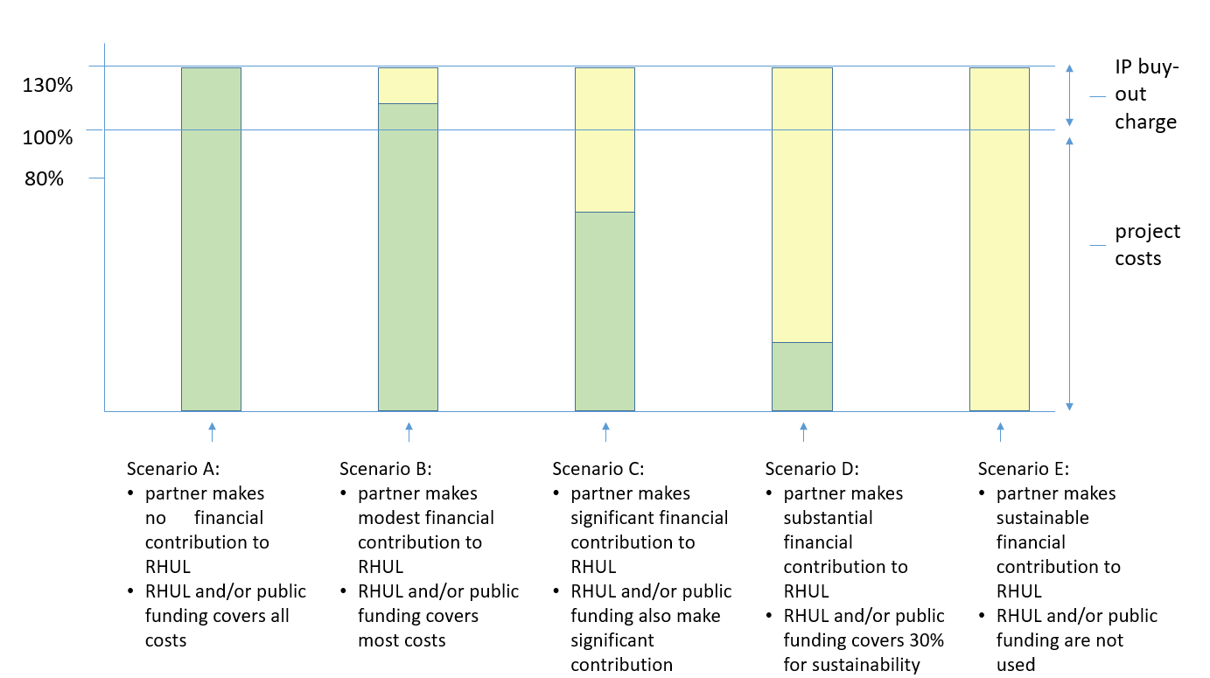
Diagram 7: an overview of different Commercial Partnering Arrangements
In this Schedule F a number of possible Commercial Partnering Arrangements are described. As shown in Diagram 7 the Commercial Partnering Arrangements have been grouped into Scenarios A to E according to the increasing financial contribution which the Third Party (i.e. sometimes also referred to as the Commercial Partner or the potential Licensee) initially provides to the University.
If the research is successful in the sense that the project results are of commercial interest to the Third Party, the Third Party should then, at a later date, reimburse the University for its outlay (i.e. the co-funding the University provided). This is in practice achieved by putting a Commercial Partnering agreement in place with the Third Party to say that the University will initially own the results and grant a time-limited option to the results to the Third Party in return for a further payment as is explained in more detail below.

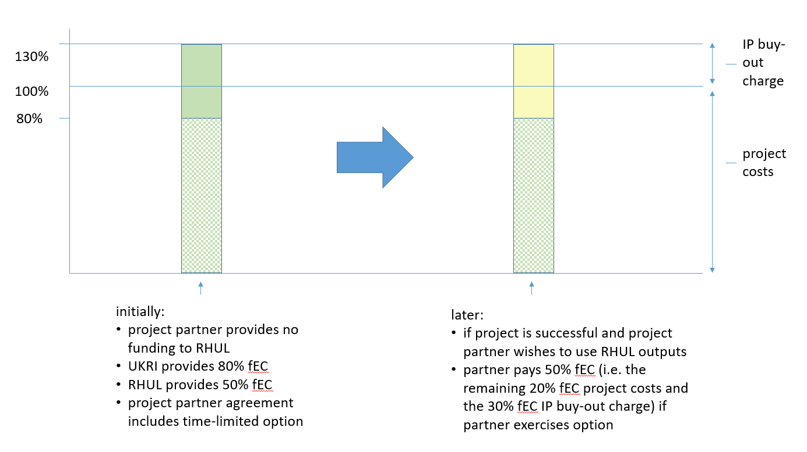
Diagram 8: Two stage deal to make Example A2 (i.e. UKRI funded project with one project partner) sustainable
Diagram 3 shows how scenario A2 (UKRI funded project with one project partner) can be improved and fulfil the University’s sustainability requirements. The individual involved in setting up such a Commercial Partnering Arrangement will need to remember to explain to the Third Party that the co-investment into the research (i.e. the in-kind contributions) constitutes the initial investment of the Commercial Partner and that the Commercial Partner will need to make a further investment (i.e. to reimburse the University for its initial outlay and to cover the IP Buyout) if the Commercial Partner wishes to use the project results for commercial purposes.
The advantage of the arrangement set out in Diagram 8 for the Commercial Partner is that it reduces the Commercial Partner’s initial investment into a technology and therefore de-risks the technology for the Commercial Partner.
However, by setting up a two-stage deal the arrangement set out in Diagram 8 is in line with the University’s sustainability requirements because all the project costs and the IP buy out sum will be recouped by the University in the event that the Commercial Partner wishes to Commercialise the project results.
In short, the University and public funders have been tasked to de-risk technology for individuals and companies who wish to invest in technology but the University also needs to ensure that its research portfolio is sustainable.
Please note that this section is specific to Commercial Partnering Arrangements where the Third Party is a commercial company and that Commercial Partnering Arrangement where the Third Party is another university or a non-profit research organisation follow the same principles as set out in this Schedule but can be more relaxed.
It is important in any agreement which underpins the Commercial Partnering Arrangement (e.g. whether this is a data licence, material transfer agreement, project partner agreement, research collaboration agreement, or studentship agreement) to capture who will fund the research project (and, if applicable, who had funded earlier relevant research) to ensure that both the University and the Third Party (i.e. the potential Licensee) can see why the proposed Commercial Partnering Arrangement fulfils the University’ sustainability requirements.
If any deviations to the guidance below are agreed as an exception via the Commercial Partnering Panel the agreement which underpins the Commercial Partnering Arrangement should define the standard Commercial Partnering Arrangement and explicitly explain that an exception was made, why the University agreed to the exception and believes this to be equitable, the level of subsidy provided by the University (and/or a public funder).

Scenario A - No financial contribution from the Third Party to the University
Example A1 - A research project which is mostly funded by UKRI (at 80% fEC), is co-funded by the University at 20% fEC, and a Third Party is prepared to give the University free access to some of its proprietary data or some of its proprietary material for use in the research project.
Example A2 - A research project which is mostly funded by UKRI (at 80% fEC), is co-funded by the University at 20% fEC, and a Third Party is prepared to be a project partner (as defined by UKRI funding rules) and give the University free advice (and optionally free access to some of its proprietary data or some of its proprietary material) for use in the research project. Diagram 8 shows how a two-stage deal can make this arrangement sustainable.
Example A3 – A research project which is mostly funded by UKRI (80% fEC for the University, sliding scale of fEC for the Third Party depending on the size of the company), is co-funded by the University at 20% fEC, and is co-funded by the Third Party by providing to itself whatever Innovate UK will not provide. This frequently occurs under an Innovate UK grant.
Example A4 - A research project which is mostly funded by a self-funded or overseas funded PhD student who covers his/her living costs and the tuition fees, is co-funded by the University by providing research expenses, supervision, and the overheads associated with lab space, and a Third Party is prepared to give the University free access to some of its proprietary data or some of its proprietary material for use in the research project.
Example A5 - A research project which is mostly funded by UKRI by providing a stipend and the tuition fees for a PhD student, is co-funded by the University providing research expenses, supervision, and the overheads associated with lab space, and a Third Party is prepared to provide the PhD student with a three month placement. This frequently occurs under a CASE studentship.
In each case listed above it is acceptable for the University to provide a time limited option to a licence to the research outputs to the Third Party (via a data licence, material transfer agreement, project partner agreement, research collaboration agreement, or a studentship agreement, as the case may be). The time limits in the option should be kept short (up to 3 months, and up to 3 months) to reflect the fact that the Third Party is not making a financial contribution to the University. The option should set out that the Third Party will need to submit a business plan to the University at the time the Third Party exercises the option to allow the University to determine whether the licence should be non-exclusive or exclusive, limited to a particular field or broad, and/or limited to a territory or world-wide. In addition, in the case of an Innovate UK project where there is more than one Third Party, the University must explain to each Third Party that is can only provide a non-exclusive licence if more than one Third Party exercises their option. If the Third Party cannot submit a business plan, the University should offer an evaluation licence to the Third Party.
In each case listed above it is not acceptable for the University to allow the Third Party to own any research outputs as set out in scenario C, scenario D, or scenario E.

Scenario B - Modest financial contribution (i.e. 1-49% fEC) from the Third Party to the University
Example B1 - A research project which is mostly funded by a self-funded or overseas funded PhD student who covers his/her living costs and the tuition fees, is co-funded by the University by providing supervision and the overheads associated with lab space, and a Third Party is prepared to provide the University with funds to cover the research expenses (and optionally free access to some of its proprietary data or some of its proprietary material) for use in the research project.
Example B2 - A research project which is mostly funded by UKRI by providing a stipend and the tuition fees for a PhD student, is co-funded by the University by providing supervision and the overheads associated with lab space, and a Third Party is prepared to provide the University with funds to cover (some of) the research expenses of the research project and to provide the PhD student with a three month placement. This frequently occurs under a CASE studentship.
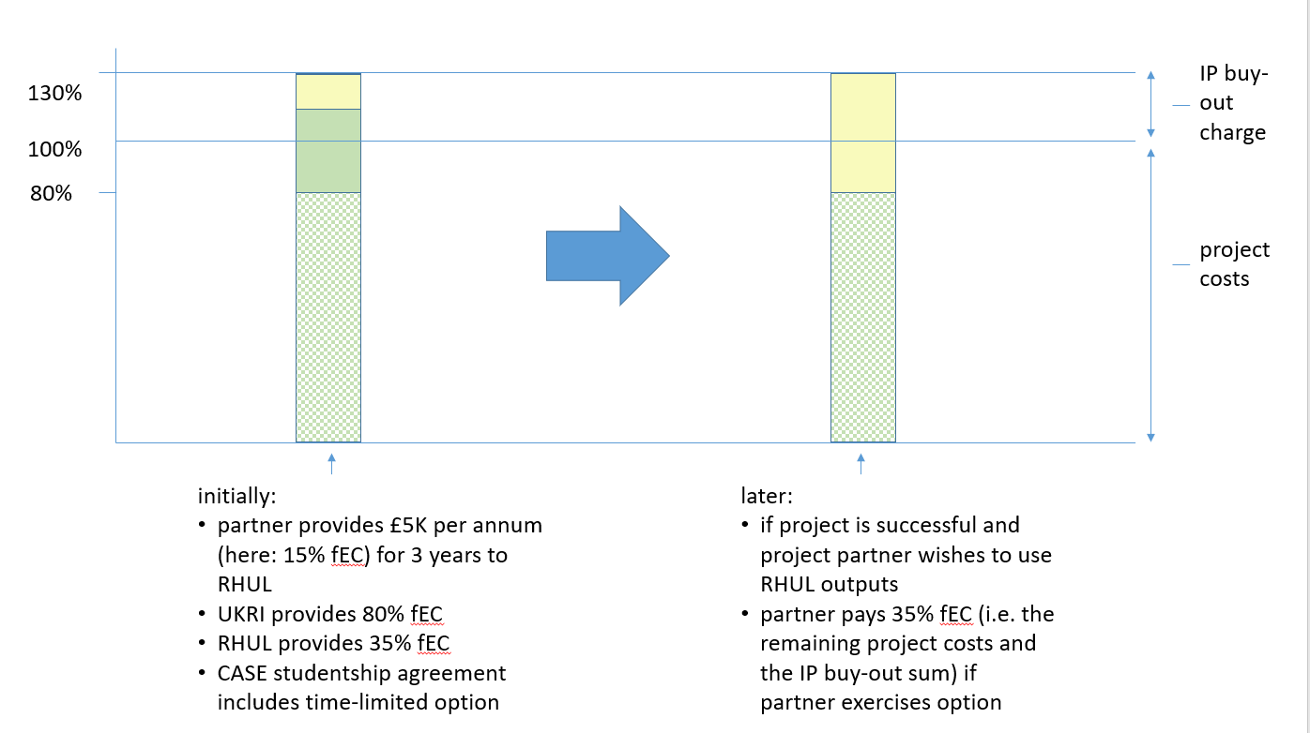
Diagram 9: Two stage deal to make Example B2 (i.e. UKRI funded CASE studentship) sustainable
Example B3 - A research project which is mostly funded by UKRI (at 80% fEC), is co-funded by the University at 10% fEC, and a Third Party is prepared to give 10% fEC to the University (and optionally free access to some of its proprietary data or some of its proprietary material) for use in the research project. This frequently occurs under a BBSRC IPA.
In each case listed above it is acceptable for the University to provide a time limited option to a licence to the research outputs to the Third Party (via a research collaboration agreement, or a studentship agreement, as the case may be). The time limits in the option can be longer than as set out in scenario A (up to 4 months, and up to 4 months) to reflect the fact that the Third Party is making a modest financial contribution to the University. The option should set out that the Third Party will need to submit a business plan to the University at the time the Third Party exercises the option to allow the University to determine whether the licence should be non-exclusive or exclusive, limited to a particular field or broad, and/or limited to a territory or world-wide. If the Third Party cannot submit a business plan, the University should offer an evaluation licence to the Third Party.
In each case listed above it is not acceptable for the University to allow the Third Party to own any research outputs as set out in scenario C, scenario D, or scenario E.

Scenario C - Significant financial contribution (i.e. 50-99% fEC) from the Third Party to the University
Example C1 - A research project which is part funded by the University providing half the stipend, half the tuition fees, the supervision costs, and the overhead associated with lab space for a PhD student, and a Third Party is prepared to co-fund by providing the University with the other half the stipend, the other half the tuition fees, and funds to cover the research expenses of the research project. This frequently occurs under a co-funded studentship.
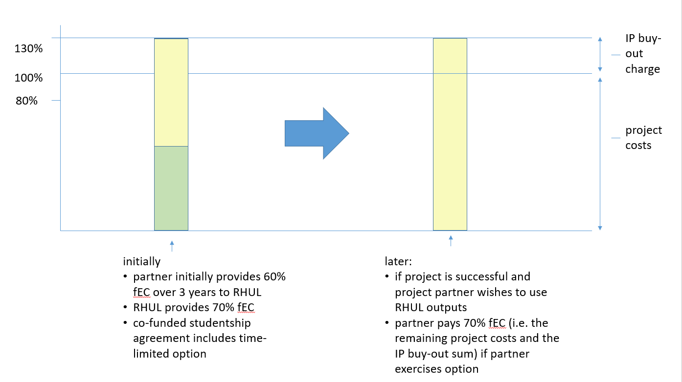
Diagram 10: Two stage deal to make Example C1 (i.e. co-funded studentship) sustainable
Example C2 – A research project which is mostly funded by a Third Party who provides the University with the direct costs of a PhD research project (i.e. the stipend, the tuition fees, and the research expenses), and the University is prepared to co-fund the project by providing the supervision costs, and the overheads associated with lab space for a PhD student. This frequently occurs under a “fully funded” studentship.
In each case listed above it is acceptable for the University to provide a time limited option to a licence to the research outputs to the Third Party (via a studentship agreement). The time limits in the option can be longer than as set out under scenario B (up to 6 months, and up to 6 months) to reflect the fact that the Third Party is making a significant financial contribution to the University. The option should set out that the Third Party will need to submit a business plan to the University at the time the Third Party exercises the option to allow the University to determine whether the licence should be non-exclusive or exclusive, limited to a particular field or broad, and/or limited to a territory or world-wide. If the Third Party cannot submit a business plan, the University should offer an evaluation licence to the Third Party.
In each case listed above it is also acceptable for the University to allow the Third Party to own the research outputs (via a studentship agreement) with an obligation to provide the University with a one-off payment to cover the University’s investment (and, if possible an IP buyout charge) within a fixed period after the end of the project.
In each case listed above it is also acceptable for the University to allow the Third Party to own some of research outputs (via a studentship agreement) provided there is a clear case that the research outputs which the University will own will be valuable in their own right.
In each case listed above it is not acceptable for the University to allow the Third Party to own the research outputs and to provide a revenue share to the University or to own the research outputs outright as set out in scenario D, or scenario E.

Scenario D - Substantial financial contribution (i.e. 100-129% fEC) from the Third Party to the University
Example D1 – A research project where the Third Party provides the University with 100% fEC but is not prepared to pay the IP buyout charge.
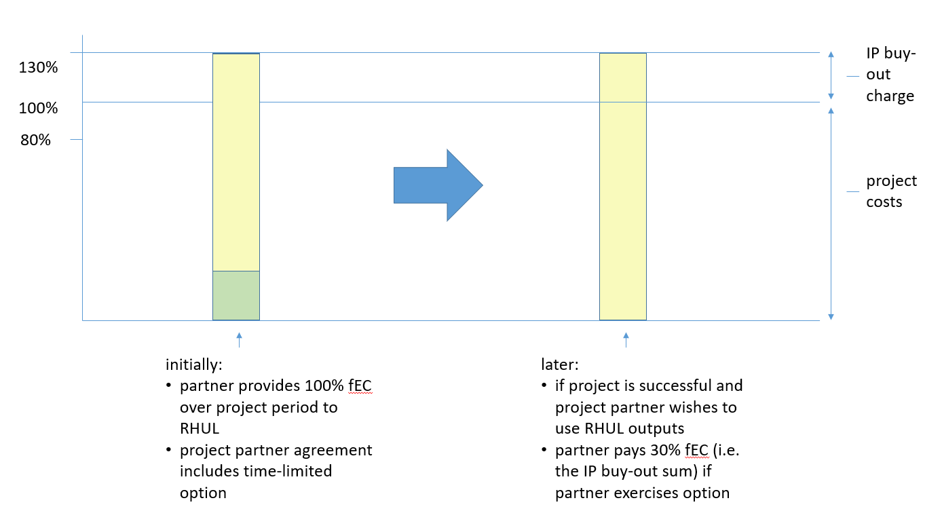
Diagram 11: Two stage deal to make Example D1 (i.e. 100% fEC collaborative research project) sustainable
In the case listed above it is acceptable for the University to provide a time limited option to a licence to the research outputs to the Third Party (via a research collaboration agreement). The time limits in the option can be longer than as set out under scenario C (up to 12 months, and up to 6 months) to reflect the fact that the Third Party is making a substantial financial contribution to the University. The option should set out that the Third Party will need to submit a business plan to the University at the time the Third Party exercises the option to allow the University to determine whether the licence should be non-exclusive or exclusive, limited to a particular field or broad, and/or limited to a territory or world-wide. If the Third Party cannot submit a business plan, the University should offer an evaluation licence to the Third Party.
In the case listed above it is also acceptable for the University to allow the Third Party to own the research outputs (via a research collaboration agreement) with an obligation to:
- provide the University with a one-off payment for the IP buyout charge within a fixed period after the end of the project, or
- put in place a revenue share with the University if Commercialisation of the research outputs is successful.
In the case listed above it is also acceptable for the University to allow the Third Party to own some of research outputs (via a studentship agreement) provided there is a clear case that the research outputs which the University will own will be valuable in their own right.
In the case listed above it is not acceptable for the University to allow the Third Party to own the research outputs outright as set out in scenario E.

Scenario E - Sustainable financial contribution (i.e. at least 130% fEC) from the Third Party to the University
Example E1 – A research project where the Third Party provides the University with 130% fEC and the IP buyout charge.

In this case it is acceptable for the University to allow the Third Party to own the research outputs outright.

SCHEDULE G
Confidential circle

As set out in diagram 12, the University is in general obliged to share its research outputs as widely as possible. However, if a Third Party wishes to invest in research that may lead to a potentially patentable invention, the University will in consultation with the affected Employee agree with a Third Party that special measures to protect confidentiality and therefore patentability are put in place for the Employee’s research group. The University calls this arrangement a “Confidential Circle”.
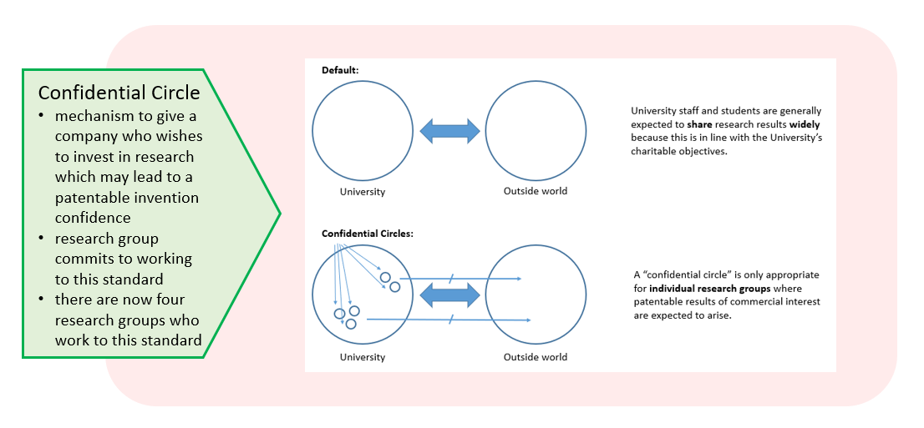
Diagram 12: rational for having Confidential Circles at the University
Where an Employee has agreed that a Confidential Circle will be put in place is his/her research group, the affected Employee will need to ensure that each Postgraduate Student and each Academic Visitor follows certain guideline and signs the required documentation.
SCHEDULE H
The University’s position on guarantees, pipelines, repayments, and warranties

The University has a duty to develop policies and support services which create the best possible environment for intellectual property (IP) to be created and to be transferred into practical use. The University, however, as a charitable organisation has to be careful not to expose itself to and to safeguard its assets from unnecessary risks. Any agreement in which the University is being asked to make a representation or give a warranty, indemnity or guarantee could potentially expose the University to risk. It therefore needs to be reviewed, in the case of IP agreements, by Research Contracts.
This Framework sets out the University’s approach to such obligations and its risks under them.

University Approach
Where the University is entering into a Commercial Partnering Arrangement, it may be asked to enter into some obligations to support its position. This is most likely to arise in the context of IP assignments or licences, but can also sometimes arise in the context of other agreements surrounding spin-out companies, which are acquiring some IP of the University or in R&D agreements, where a Funder is acquiring some rights in IP. The University’s approach is that, where the third party is providing real value to the University, it will back up the IP which it is putting into the deal with some limited warranties.
- Indemnity - The University will not provide an indemnity with respect to IP because of the increased liabilities involved.
- Representation -The University also does not wish to give representations, because of the complexities that can arise with them. Any pre-contractual representation must be excluded by what is often known as an “entire agreement” clause.
- Warranty -The warranties that the University is prepared to give will vary slightly depending upon the nature of the transaction. Essentially, they might comprise a limited warranty that the University is the registered proprietor of or applicant for the IP in question; and has not previously assigned or licensed the IP in such a way as would prevent the current agreement being entered into. The warranty of ownership must be limited to the awareness of the University and that awareness will be based solely upon information supplied by named individuals.
Additional warranties, such as, the IP is not encumbered in any way, the other party’s use of the IP will not infringe any third party rights, and/or the IP is valid, increase the University’s risk and go beyond the warranties/obligations which the University is prepared to offer and cannot be accepted.
It is also important to be aware of assignments of IP which assign “all rights, title and interest” in the IP. The University will only ever assign “its right, title and interest” in the IP.

Pipelines
Pipelines are created where the University grants to a Commercial Partner, Self-Commercialisation Company or Spin-Out Company automatic rights to future technology arising from the University. Giving away such IP rights to future technology, such as improvements, is giving away an asset of the University for nothing. As a charitable institution, the University cannot do this.

Repayments
The University will not enter into arrangements under which there could be repayment of sums paid to the University, such as an agreement including a repayable deposit. A repayment does not include a claim for damages.

Limitation of Liability
Where the University has entered into warranties or given other commitments to the other party to an agreement, it must limit its liability. That liability should be capped by reference to the financial benefit which the University receives at the time of that agreement, such as the immediate cash consideration (excluding any VAT) which the University has received for the assignment of IP. In the case of a licence, it might be linked to royalties received over a specified period.
For Spin-Out Companies (and in some cases Self-Commercialisation Companies), the University will only own a proportion of that company’s shares and so the University’s liability must be capped accordingly. It must also be made clear that, if further investment is made into the Spin-Out Company (or the Self-Commercialisation Company) later, then the University will not give further warranties or increase the University’s liability at that stage.
The University also expects to limit the time within which any claims must be brought.

SCHEDULE I
Detailed provisions about the sharing of Net Income

The University will continue to share the Net Income in accordance with the 2011 Exploitation of Inventions and Patents Code of Practice for any income received for a technology which was notified to Knowledge Exchange up until 31st December 2020 provided that the Commercial Partnering Arrangement for that technology was signed up until 31st December 2020.
The University will share the Net Income in accordance with this Schedule for any income received i) for a technology which was notified to Knowledge Exchange on or after 1st January 2021, or ii) under a Commercial Partnering Arrangement which the University entered into on or after 1st January 2021 (irrespective of when the technology was first notified to Knowledge Exchange).

1. An Incentive to disclose Commercialisable University IP
Inventor/School/University Share - The Net Income will be shared as follows:
Total Net Income | Originator(s) | School(s) | University
up to £5,000 | 100% | 0% | 0%
£5,001 - £75,000 | 50% | 20% | 30%
 |  |  | 15% | 15% for Patent Development Fund
over £75,000 | 30% | 30% | 40%
 |  |  | 15% | 25% for Patent Development Fund
In the table above School(s) means the School(s) from which the University IP originated.
Sharing of the Originators’ portion of the Net Income between Originators - if there is more than one Originator, the portion of the Net Income due to the Originators (as set out in the table above) needs to be further shared between the individual Originators. The proportion each Originator receives will reflect the contribution of each Originator as set out in the relevant IP disclosure form unless the Originators have agreed in writing at a later date via an amendment to the IP Disclosure Form on a different proportion.
Sharing of the Originators’ portion of the Net Income with Contributor – in some cases the Originator(s) may feel that the portion of the Net Income due to the Originators (as set out in the table above) should also be shared with Contributor(s). The Originator may make such a request when a payment is due and should record his or her intention in writing via an amendment to the IP Disclosure Form. If there is more than one Originator then all Originators must be in agreement and record their intention via an amendment to the IP Disclosure Form. For the avoidance of doubt, Contributor(s) do not have a right to any share of the Net Income and can only receive a share of the Net Income if the Originator(s) request this.

2. Clarification about Net Income
The University records all Net Income which relates to a technology under the relevant technology code.
Net Income includes any income the University receives under any Commercial Partnering Arrangement, but does not include:
- shares in a Spin-Out Company or a Self-Commercialisation Company or any proceeds from such shares; or
- any funding or payment made to support a Student; or
- income or capital representing payments for, or on account of, research (whether expressly or which have been taken into account in seeking to recover full economic costs);
- income or capital representing payments (whether lump sum, royalty or otherwise) for a licence of Third Party IP created during the course of a research programme, up to and including the full economic cost of such research to the University less the amount of such full economic cost as has been paid by such Third Party or an affiliate of it to the University for such research.

3. Clarification about deduction of direct costs
The University records all direct costs which relates to a technology under the relevant technology code.
At the point that Net Income is distributed for the first time (i.e. the round of income distribution) the University will pay any employer’s national insurance contribution if the University makes a payment to an employee in order to pass the Originator(s)’ share to an employee.
In the first instance, the employer’s national insurance contribution made in connection with passing an Originator(s)’ share to an employee will be deducted wholly from the University’s share. In the second instance if the University’s share is not sufficient to cover the employer’s national insurance contribution, the employer’s national insurance contribution will be deducted (in part) from the School(s)’ share.
As the employer’s national insurance contribution is a cost to the University (and the School), the University will record this cost as a direct cost under the relevant technology code. This means that if there is a further round of income distribution, the employer’s national insurance contribution of the earlier round will be deducted as a direct cost from any additional Net Income.

4. Teaching Material and University Material
No sharing of Net Income for Teaching Material - Even though creating Teaching Material is one of the University’s core purposes, the University will usually grant an Originator a share of the Net Income arising out of the Commercialisation of Teaching Material as set out above. However, the University cannot grant such a share where:
- specific time has been made available during his or her employment (including a paid sabbatical) to an Originator for his or her contribution to the creation of any Teaching Material; or
- the Originator is specifically employed by the University to create Teaching Material (whether as all or part of his or her employment); or
- the authorship of such Teaching Material results from simultaneous or sequential contributions over time by many Employees and/or Students, such that authorship of the relevant Teaching Material cannot readily be attributed to an identifiable set of authors; or
- the content of such Teaching Material is relevant to a part of the University’s strategy, e.g. teaching of a specific University course or a planned potential income source for any part of the University, except in exceptional cases
where the University recognises that any such Teaching Material is an important, breakthrough material.
No sharing of Net Income for University Material - Similarly, as University Material are produced for a University administrative or other purpose, an Originator will not be entitled to any share of the Net Income arising out of the Commercialisation of University Material.

5. Tax and National Insurance
Deduction at Source for Employees - All payments to be made by the University to an Originator (or Contributor) pursuant to this Schedule I (Detailed provisions about the sharing of Net Income) will be subject to the deduction of any applicable income tax, employee’s national insurance, apprenticeship levy, and any other equivalent deductions at source.
Declaration and Payment - If an Originator is no longer an Employee, then, before the University makes any payment to him or her, the University will require:
- a written confirmation from the Originator that he or she will declare such payment on all relevant tax returns and indemnify the University against any tax, national insurance, interest and penalties payable in respect of such payment or allotment; and
- actual payment of any known or reasonably anticipated tax, national insurance, interest and penalties which may arise in respect of such payment/allotment, and the University is authorised to deduct from any payment due to such former Employee.
Indemnity - If income tax and/or national insurance subsequently becomes payable on revenue sharing payments made to an Originator, then the Originator must indemnify the University against any tax, national insurance, interest and penalties in respect of such payments.

6. Alternative Arrangements where there are three or more Originators
The University will share the Net Income with the Originator(s) unless there are more than three Originators and it would be too onerous on the University to share the Net Income with the Originators. If staff in Research and Innovation believe that sharing the Net Income with the Originators is too onerous they should follow the process set out in section 6.16 (Exception Procedure) and explain why it would be equitable to pass the Originator’s share to the Department (in addition to the Department’s share). For the avoidance of doubt, if the Commercial Partnering Panel agrees with the request, it is not necessary to seek approval from each Originator.

7. New employer to take on University’s obligation to share Net Income if the Originator transfers to another organisation
The University will as a rule pass any funds due to any Originator to the Originator even if he or she has ceased to be an Employee, a Postgraduate Student or an Academic Visitor for any reason. However, if an Originator transfers to another organisation and the University agrees to assign the relevant University IP to the other organisation and passes the obligation to share Net Income to the other organisation via a formal agreement (typically an assignment with future revenue share agreement) then the University’s obligation to share Net Income with the transferring Originator will cease.

8. Waiver procedure
An Originator (or Contributor if nominated by an Originator) who is an employee of the University may waive all or part of any payment due to him or her under a Licence. For the avoidance of doubt, i) the waiver will need to be made via a Waiver Form, ii) each Originator (or Contributor) will need to complete a separate Waiver Form for each Licence, iii) any Waiver Form will need to be signed before the relevant Licence is signed, iv) any Waiver Form, once signed, cannot be revoked unless the Originator leaves the employment of the University, and v) an Originator (or Contributor) cannot request that a waiver be put in place after the relevant Licence has been signed.

9. Missing Originator
Notification of Address – It is the obligation of each Originator who ceases to be an Employee, a Student, or an Academic Visitor, to notify Knowledge Exchange of his or her current email address to allow Knowledge Exchange to get in touch with the Originator in the event that there is a sharing of Net Income. If an Originator fails to provide Knowledge Exchange with his or her current email address, then he or she will be treated as a missing Originator and the University will retain any unclaimed share of Net Income for such missing Originator. For the avoidance of doubt, the University will not be a trustee of any such unclaimed share of Net Income.
Unclaimed Amounts – Any share of Net Income which remains unclaimed for three years from the date the relevant Income is received by the University will, after that date, be forfeited and will revert to the University, who will distribute such Net Income after excluding the missing Originator from the calculations.

10. Deceased Originator
In the case of the death of an individual due a share of income, that share of any income will be payable to the estate of the deceased.

11. Example of how the Net Income is distributed
It is easiest to understand how the Net Income is distributed by looking at specific examples. In the table below you can see how much the Inventor(s), the School and the University would receive depending on how much income the University receives.
The details of the scenario are as follows:
- there are two Inventors - one an Employee and one a former PhD student
- both Inventors are connected to the same School
- the Inventors have agreed that the Employee’s inventive contribution was 30% and the former PhD student’s contribution was 70%
- the University’s expenses in securing patent protection have been £7,700

Calculation of Net Income |  |  |  | Distribution of Net Income
Income received | Expenses | Net Income |  | Inventors |  | School | University
 |  |  |  | Em-ployee | former PhD student |  | general funds | Patent Development Fund
5,000 | 7,700 | 0 |  | - | - | - | - | -
10,000 | 7,700 | 2,300 |  | 100% |  | 0% | 0% | 0%
 |  |  |  | 30% | 70%
 |  |  |  | 690 | 1610 | 0 | 0 | 0
 |  |  | total | 690 | 1610 | 0 | 0 | 0
20,000 | 7,700 | 12,300 | up to 5K | 100% |  | 0% | 0% | 0%
 |  |  |  | 30% | 70%
 |  |  |  | 1,500 | 3,500
 |  |  | 5K – 75K | 50% |  | 20% | 15% | 15%
 |  |  |  | 30% | 70%
 |  |  |  | 1,095 | 2,555 | 1,460 | 1,095 | 1,095
 |  |  | total | 2,595 | 6,055 | 1,460 | 1,095 | 1,095
100,000 | 7,700 | 92,300 | up to 5K | 100% |  | 0% | 0% | 0%
 |  |  |  | 30% | 70%
 |  |  |  | 1,500 | 3,500 | 0 | 0 | 0
 |  |  | 5K – 75K | 50% |  | 20% | 15% | 15%
 |  |  |  | 30% | 70%
 |  |  |  | 6,750 | 15,750 | 9,000 | 6,750 | 6,750
 |  |  | total | 8,250 | 19,250 | 9,000 | 6,750 | 6,750
500,000 | 7,700 | 492,300 | up to 5K | 100% |  | 0% | 0% | 0%
 |  |  |  | 30% | 70%
 |  |  |  | 1,500 | 3,500 | 0 | 0 | 0
 |  |  | 5K – 75K | 50% |  | 20% | 15% | 15%
 |  |  |  | 30% | 70%
 |  |  |  | 10,500 | 24,500 | 14,000 | 10,500 | 10,500
 |  |  | over 75K | 30% |  | 30% | 15% | 25%
 |  |  |  | 30% | 70%
 |  |  |  | 37,557 | 87,633 | 125,190 | 62,595 | 104,325
 |  |  | total | 49,557 | 115,633 | 139,190 | 73,095 | 114,825

The table shows that, e.g. if the University receives £100K, it will after deducting its expenses, distribute £8,250 to the employee*, £19,250 to the former PhD student*, £9,000 to the School, and place £6,750 in the Patent Development Fund. (The asterisk means that this is the figure before deduction of income taxes).
Where the University receives Income in more than one instalment, the later income will be treated as additional Income rather than new Income. For example, if the University first received £20,000 it would distribute the Net Income as shown in the table above. If the University later received £100,000 the second round of income would be distributed as shown in the table below (assuming it had not incurred further expenses).
Calculation of Net Income |  |  |  | Distribution of Net Income
Income received | Expenses | Net Income |  | Inventors |  | School | University
 |  |  |  | Em-ployee | former PhD student |  | general funds | Patent Development Fund
100,000 | 0 | 100,000 | 5K – 75K | 50% |  | 20% | 15% | 15%
 |  |  |  | 30% | 70%
 |  |  |  | 9,405 | 21,945 | 12,540 | 9,405 | 9,405
 |  |  | over 75K | 30% |  | 30% | 15% | 25%
 |  |  |  | 30% | 70%
 |  |  |  | 3,357 | 7,833 | 11,190 | 5,595 | 9,325
 |  |  | total | 12,762 | 29,778 | 23,730 | 15,000 | 18,730

This is because the “up to £5K” allocation was used completely under the first payment and £7,300 of the “£5K - £75K” allocation was used under the first payment. Therefore only £62,700 can now be paid under the “£5K - £75K” allocation and the remaining £37,300 are paid under the “over £75K” allocation.

SCHEDULE J
The University’s position on non-commercial partnering arrangements

The University is prepared to enter into a non-commercial partnering arrangement in the context:
- an invention which relates to a new active ingredient, where the University will follow the “Essential Medicines” process as set out below, and
- a social enterprise which may benefit the local community, where the University will follow the “Social Enterprise” process as set out below.

Essential Medicines
The University is committed to supporting fair access to medicines for those in low income countries. Where relevant, the University will implement a technology transfer strategy that promotes the availability of an essential medicine in such countries whilst recognising any Commercial Partner’s legitimate business concerns. In particular, the University achieves this by:
1. filing and prosecuting new active ingredient patent applications in low income countries only as necessary (for example, to provide development and marketing leverage for new products, or to exert leverage over global licensees, or to promote product manufacture in the country);
2. including, where possible, provisions in its stand-alone Licences that seek to promote the manufacture of medicines or the availability of active pharmaceutical ingredients at affordable prices to low income countries.
The University expects any Commercial Partner to appreciate and cooperate with the University to support the University with its commitment.

Social Enterprises
The University is committed to supporting the local community. Where relevant, the University will implement a technology transfer strategy that promotes the availability of a technology to the local community whilst recognising any Commercial Partner’s legitimate business concerns. In particular, the University achieves this by including, where possible, provisions in its stand-alone Licences that allow a local enterprise to use the same technology locally only.
The University expects its any Commercial Partner to appreciate and cooperate with the University to support the University with its commitment.

