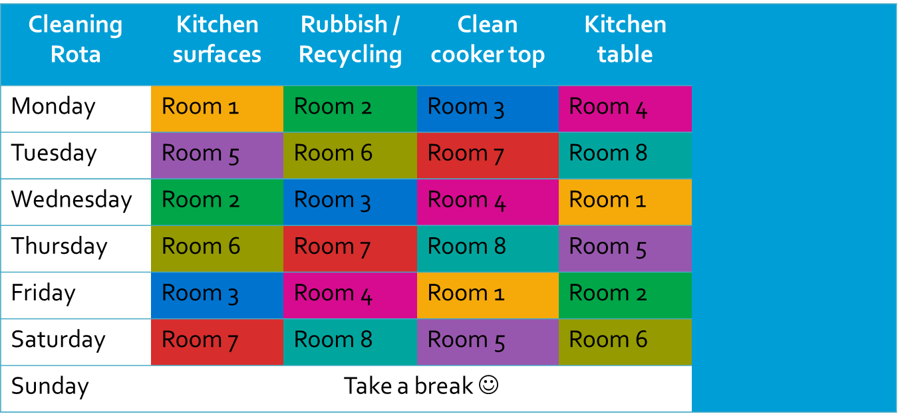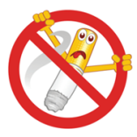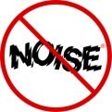

Speak to us by visiting the Student Services Centre, Davison Building between 7-9pm Monday to Sunday (term time)

Email us at **hall.life@royalholloway.ac.uk**

**No noise after 11pm in hall**

**End of Term Reminder**

**Remember to empty your food from the fridge and leave your accommodation tidy.**

**All public areas are cleaned and paper products replenished on a daily basis, Monday to Friday, excluding public holidays and College discretionary days. These include communal bathrooms, showers and toilets, corridors and stairs. Please help by keeping work surfaces clear, toilets clean, putting all litter in bins and taking out your recycling.**

**It is a disciplinary offence if you or your guests smoke in halls**

**A CLEAN HALL IS A HAPPY HALL!**

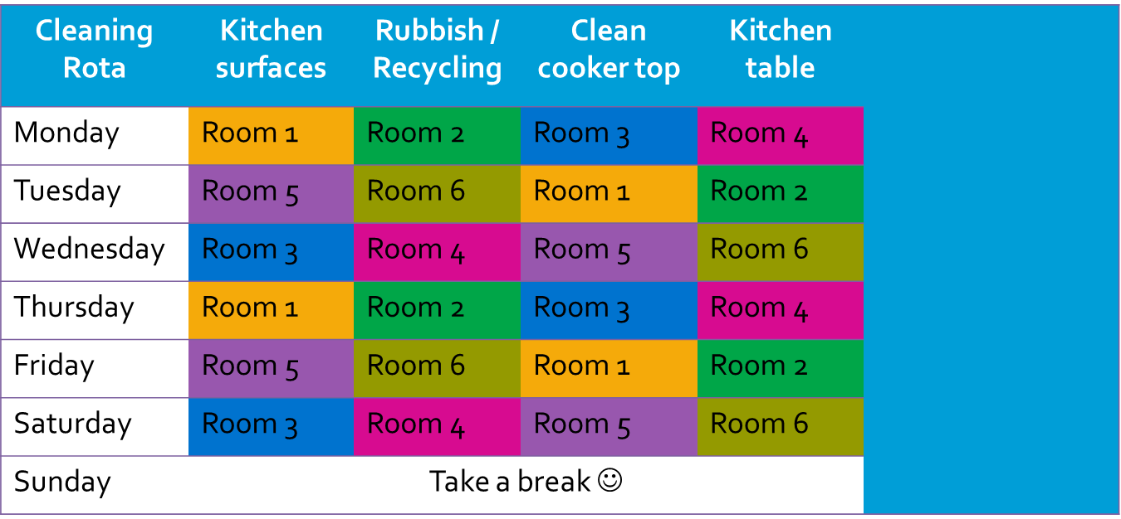

**No noise after 11pm in hall**

**End of Term Reminder**

**Remember to empty your food from the fridge and leave your accommodation tidy.**

**All public areas are cleaned and paper products replenished on a daily basis, Monday to Friday, excluding public holidays and College discretionary days. These include communal bathrooms, showers and toilets, corridors and stairs. Please help by keeping work surfaces clear, toilets clean, putting all litter in bins and taking out your recycling.**

**It is a disciplinary offence if you or your guests smoke in halls**

**A CLEAN HALL IS A HAPPY HALL!**

Speak to us by visiting the Student Services Centre, Davison Building between 7-9pm Monday to Sunday (term time)

Email us at **hall.life@royalholloway.ac.uk**

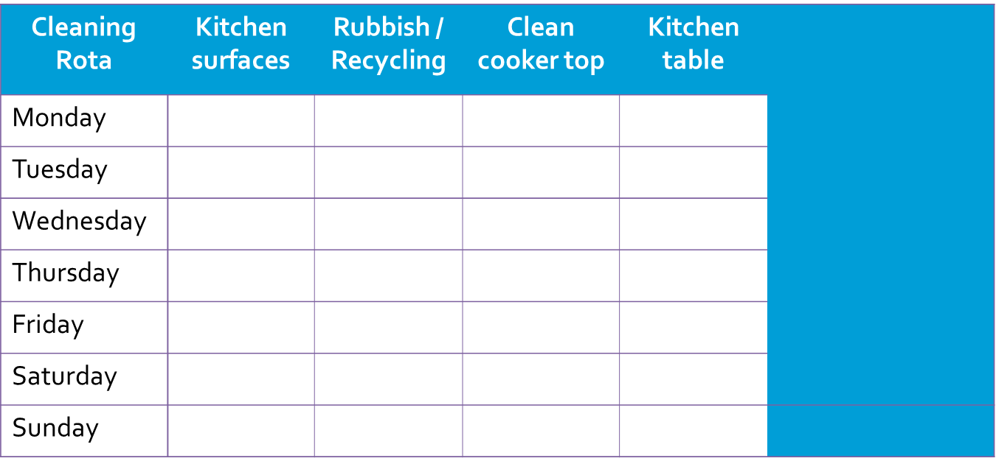

**End of Term Reminder**

**Remember to empty your food from the fridge and leave your accommodation tidy.**

**All public areas are cleaned and paper products replenished on a daily basis, Monday to Friday, excluding public holidays and College discretionary days. These include communal bathrooms, showers and toilets, corridors and stairs. Please help by keeping work surfaces clear, toilets clean, putting all litter in bins and taking out your recycling.**

**A CLEAN HALL IS A HAPPY HALL!**

**No noise after 11pm in hall**

**It is a disciplinary offence if you or your guests smoke in halls**

Speak to us by visiting the Student Services Centre, Davison Building between 7-9pm Monday to Sunday (term time)

Email us at **hall.life@royalholloway.ac.uk**